UI/UX Project Outline - NookBook

Group 4

Kaleb Jubar, Aggrey Nhiwatiwa, Samet Berk Özdemir, Livio Reinoso

# Project Check-in 1 (P-1)

## Part 1 - App Concept

Our app concept is a companion app + game wiki for Animal Crossing: New Horizons (ACNH). This app will provide some common features found in similar apps, such as a collection tracker, villager overview, and event calendar. It will also contain additional tools that link directly to the user’s save game*, such as push notifications when certain things happen in game, a dynamic island map, and more. Finally, it will also include wiki integration in appropriate parts of the app to avoid the user having to switch apps repeatedly if they wish to know more about an in-game item, villager, feature, etc.

###### *Disclaimer:

*We are aware that integrating directly with the save game, especially remotely via a network connection, is absolutely not something Nintendo would ever actually allow a third party application to do, but since we won’t actually be writing code for the app, we figured this is an acceptable caveat as it opens up a lot of possibilities for app features that wouldn’t normally be doable. We’ll just live in our imaginary fantasy world where Nintendo doesn’t send cease and desist letters to anyone coming close to their IPs (except Palworld, they dodged that bullet somehow) for the purposes of this project.*

This app wouldn’t necessarily impact the overall market of video game companion apps, but it would certainly have an effect on the market for specifically ACNH companion apps, and possibly other indirect competitors like similar companion apps for other farming/life sim games. Per our research presented in this report, there are a handful of decent apps for tracking progress in ACNH, but most of them only have completionist-related features and don’t have the ability to integrate directly with the user’s save game. By adding this integration, our app blows the capabilities that a companion app can have wide open, as well as eliminating some of the tedium that other apps have because the user has to manually enter all of their data. The aim is to make a one-stop-shop app that caters to completionists and more casual players alike.

## Part 2 - Competitor Analysis

### Table Analysis

|  | **ACNH Guide** | **ACNH Travel Guide** | **Pocket Guide** | **NS Online (NookLink)** | **Valley Planner** | **Unoff SV Companion** | **Our App** |
| --- | --- | --- | --- | --- | --- | --- | --- |
| Type of competitor | Direct | Direct | Direct | Direct | Indirect | Indirect |  |
| Pricing | Ad supported | $3.99 (iOS) | Free with no ads | $24.99 / year | $3.59 (Android)  $3.99 (iOS) | Ad supported, “pro” upgrade for $3.49 (Android) | 7 day free trial (account required), $2.99 for permanent access after trial |
| OS | Android & iOS | iOS only | Android only | Android & iOS | Android & iOS | Android, Chromebook, & iOS | Android & iOS |
| Avg rating | 4.6 - Android phone  4.8 - iOS | 4.9 - iOS | 4.9 - Android phone  4.8 - Android tablet  4.0 - Chromebook | 3.1 - Android phone  3.0 - iOS | 4.4 - Android phone  3.9 - Android tablet  5.0 - iOS, only 5 reviews | 4.5 - Android phone  4.4 - Android tablet  4.1 - Chromebook  4.6 - iOS |  |

| Island map | No | No | Mystery islands only | No | No | No | Yes |
| --- | --- | --- | --- | --- | --- | --- | --- |
| Collection tracker | Yes | Yes | Yes | No | Yes | Yes | Yes |
| Villagers tracker | Yes | Yes | Yes | No | Yes | Yes | Yes |
| Events tracker | Yes | Yes | Yes | Yes | Yes | Yes | Yes |
| Chat feature | No | No | No | Yes | No | No | Yes |
| Push alerts | No | No | Yes | No | No | No | Yes |
| In-app shop | No | Yes | No | Yes | No | No | Yes |
| Top strengths | Collection tracker for all items and craftables. | Easy-to-use interface and ad-free app, highly rated. Lock Screen Widgets. | Free without ads. Multitude of push notification types. | Direct integration with the game. Island newspaper | Detailed villager information. | Filtering and searching functions for all sections of the app. | Direct integration with the game and features that actually harness this, rather than novelties. |
| Top weaknesses | Lacks integration with the game. No alerts. | Only available for one platform. | Only available for one platform and lacks integration with the game. | Requires online subscription. | Lacks integration with the game. | UI is a bit clunky and cluttered, ads are intrusive. | Account is required, short free trial period. |

### Analysis Results

1. What are some things that your competitors are doing well overall?

Most competitors have collection, villager, and event trackers with varying degrees of robustness, which are core features that users of this genre of app are looking for. In general, they are structured well and most provide at least minimal filtering or sorting options. Most competitors have simple UIs that are easy to navigate and use.

2. What are some things that your competitors are doing poorly overall?

None of the competitors have a dynamic island map, and few of them have other features like friends, chat, push notifications, and direct game integration. The only app providing direct integration with the actual game on your Switch is rated very low and requires a yearly subscription to Nintendo Switch Online. In addition, only a few of the apps seem to allow offline usage, and none of them have deep wiki integration so users trying to find more information about game systems, villagers, items, etc. have to use a separate app or website.

3. What app store(s) are your competitors on? Do they have good or bad reviews overall? Is there any information in the bad reviews that might help you for your app?

Both our direct competitors and indirect competitors are mostly on both main app stores. They do have good reviews overall, though there are some bad reviews. In particular, the Nintendo Switch Online App suffers low reviews - this comes mostly from users complaining about not having certain functionality or their features overlapping with other applications. From this, we can infer what features users are looking for the most. They are specifically looking for apps to run in the background that can provide news from the game, as well as having a section where you can see when your friends are connected so you can chat and play with them.

4. What are your initial ideas on how your app will be different and/or better than what already exists? Why will users want to use your app instead?

The major difference between our app and our competitors is that in addition to the major completionist features provided by other apps, our app will also have quality of life features for more casual players as well as wiki integration for an all-in-one experience. Thanks to our app’s direct connection to your saved game, there are a lot more possibilities available for extra features that can cater to all players, not just superfans and completionists.

5. Based on your research, list at least 3 features that will be crucial to your app’s success. Be sure to mention how your research helped you choose these features!

*Integration with the game directly via Nintendo Network*

Our application will be directly integrated into ACNH, providing a seamless experience for users. This can allow many new features that do not currently exist in any competing apps, like a dynamic island map, notifications about events happening on your island in real-time, and automatically syncing collection progress.

*Push notifications to alert users about in-game events*

A big part of lower rating reviews were complaining about having no notifications and missing out on things.

The application will notify users whenever certain actions are triggered, such as:

* A new villager visits your island.
* A bug or fish that you haven’t caught yet has started spawning for this season.
* One of your villager’s birthdays is coming.
* A vendor is visiting the island.
* Turnip prices are within a preset price range.
* The construction of a bridge or ramp is completed.
* A fishing tournament is coming next weekend.

*Having a collection tracker for all in-game items*

Even though this feature is included in most of our competitors' apps, it was not on Nintendo’s official app, which was a big complaint from many users: having to rely on a third-party app to know what they have and have not achieved in the game. By synchronizing the app’s collection trackers to the user’s save file, users are able to eliminate the tedium of manually entering all of their registered collection items and maintaining the list.

## Part 3 - Target Audience

Some broad assumptions helped us discover our target market, which enabled us to be more specific, leading to the discovery of our target audience. We initially factored in age, location, household status and interests. Our app will be suitable for nearly every age, due to the PEGI rating of ACNH being ages 3 and up. A younger child, however, may not own a smartphone, but it can be assumed that a parent could aid a younger child with the application due to many of our competitors allowing multiple profiles; this would require the parent to have a keen interest in the app themselves, though.

Location is also not much of a constraining factor on our target audience, as the only country where Animal Crossing is banned is in China. Not only is the game not available in China but from further competitor research we discovered that our competitors, such as the ACNH guide do not have their companion apps available in the China app store (Sensortower, 2021), reinforcing this point.

Furthermore, household status would have no real bearing on whether individuals comprise our target audience, as long as they own a Nintendo Switch and the ACNH game.

The assumed interests of our target audience would be existing ACNH players who are completionists, who value completing the game in its entirety, as well as those ACNH players that do not have regular access to a PC or want to quickly check the status of their island.

In general, the target market for our app would simply be people who own the ACNH game. However, our target audience from the above assumptions are more specific, such as members of the target audience being from a location outside of China, due to the game being unavailable there (Wikipedia, 2024). Apart from this, due to ACNH being a casual gaming experience, our app will be suitable for the wide range of ages that play ACNH. For example, there is an 89 year old player, Audrey Buchanan, who played over 3500 hours in Animal Crossing New Leaf and also plays ACNH (Animal Crossing Wiki, 2024). They even have posted videos of their ACNH island progress on a YouTube channel which can be seen here: <https://www.youtube.com/watch?v=didkW-LOWCs> (phubans (via YouTube), 2020).

Despite drawing some conclusions from broad assumptions, we have conducted some user profiling in order to be more specific in regards to potential target audience member profiles, which will provide a strong basis to which we can create target personas further down the line.

The psychographic profiling of our target audience are people who value playing ACNH as part of their lifestyle, as well as more dedicated ACNH players who are interested in trying to complete the game, as our app intends to provide collection trackers. Our target audience may also include those who really value their time and want a quick and on-the-go way to check the status of their game without having to start up the game to do so, as our application limits the impact of the tedious task of getting a user to launch a game on a device they may not use all the time. People tend to use their phones daily regardless, so our app will enable people to incorporate our app into their existing workflow. In summary, the psychographic profile of our target audience member would be an individual who values both playing ACNH as part of their lifestyle, as well as saving time. In addition, this profile includes people who are of the opinion that games are there to be completed.

The demographic profiling of our target audience includes people that are located in countries where ACNH is sold (all countries except China). As previously discussed, age is not a major factor due to the wide age range of players, as highlighted by the age rating of ACNH itself being 3+, and older players such as Audrey Buchanan. Income also does not play a major factor, due to our app being free to use. Marital status and gender also do not create a more specific user profile due to these demographic factors not having much of an impact on a companion app for a game made for an extremely broad playerbase.

As many of the typical demographic factors are not exclusions for a user profile, some other demographic factors should be considered. As opposed to employment status and marital status being considered demographically, these factors have a large effect on the amount of "free time” a member that fits our psychographic user profile may have. To summarize our demographic profiling, our users can be of a wide age range, any gender and marital status, as well as from different employment statuses and income brackets (due to our app being initially free to access followed by a small one-time fee). However, any combination of these demographic factors that decrease a user's available time for gaming may make these users more likely to use our application as it saves the user time.

In conclusion, both psychographic and demographic profiling have enabled us to be more specific in identifying members of our target audience and the attributes which they possess. This can help us to tailor our user interface and app concepts to enable the profiled user to have a good user experience.

# Project Check-in 2 (P-2)

## Part 1 - User Research and Analysis

### Data Analysis - Introduction

Prior to starting our research we initially identified our target audience. We deemed our base target audience to be people who played video games, with a more narrow target audience of those who play the game Animal Crossing: New Horizons (AC:NH). Our research, especially our qualitative research would enable us to create user personas, as well as a user scenario map and storyboard, using the motivations of our app concept.

Both quantitative and qualitative data were essential for us to use. Quantitative data is an important source of factual data. Gathering this data enabled us to find areas to target for our qualitative analysis, which allowed us to uncover user feelings and motivations about our potential app concept.

#### Research goals

The research goals we intended to meet were as follows:

* Obtain qualitative and quantitative information about our target audience.
* Explore their current method of satisfying the features that our app will deliver. Including their experiences with it; good and bad.
* Identify existing pain points as well as the motivations and needs of our target audience.
* Confirm the alignment of market needs to our app concept.
* Prove our initial concept ideas.

#### Methodology

For our quantitative data, we used a survey which enabled us to obtain quick insights into our users. We asked questions based on demographics, video game engagement, and AC:NH companion app interest, as the latter questions were only applicable to those who played AC:NH. We also obtained some psychographic data through the questions we asked (despite not having its own specific section in the survey). There were 15 questions that could be answered by anybody, whilst there were 7 additional questions for those who have played AC:NH to get some responses from a more narrow and app concept-specific subset of our target audience. The 33 participants were all gamers (our target market). Google Forms was used to generate and distribute our survey.

For our qualitative data, we conducted interviews consisting of 10 questions. The 2 participants were specific members of our target audience, AC:NH players. The questions related to the participants' experience with the game itself, as well as their experience with other companion apps. Finally, the participants were asked about our app concept, prior to which they were given an overview of our app concept.

For our quantitative analysis we used data visualization, whilst for our qualitative analysis we grouped together common themes.

#### Bias

As our survey questions were nearly all closed-ended, we were able to eliminate a lot of biases. For our interview, we ensured that our questions did not assume positive or negative experiences or try to lead participants to a specific answer. For example, instead of asking “What do you like about our app concept?”, we simply asked “What are your thoughts on our app concept?”, which enabled us to reduce bias.

### 

### Survey - Analysis

#### Demographics - Results

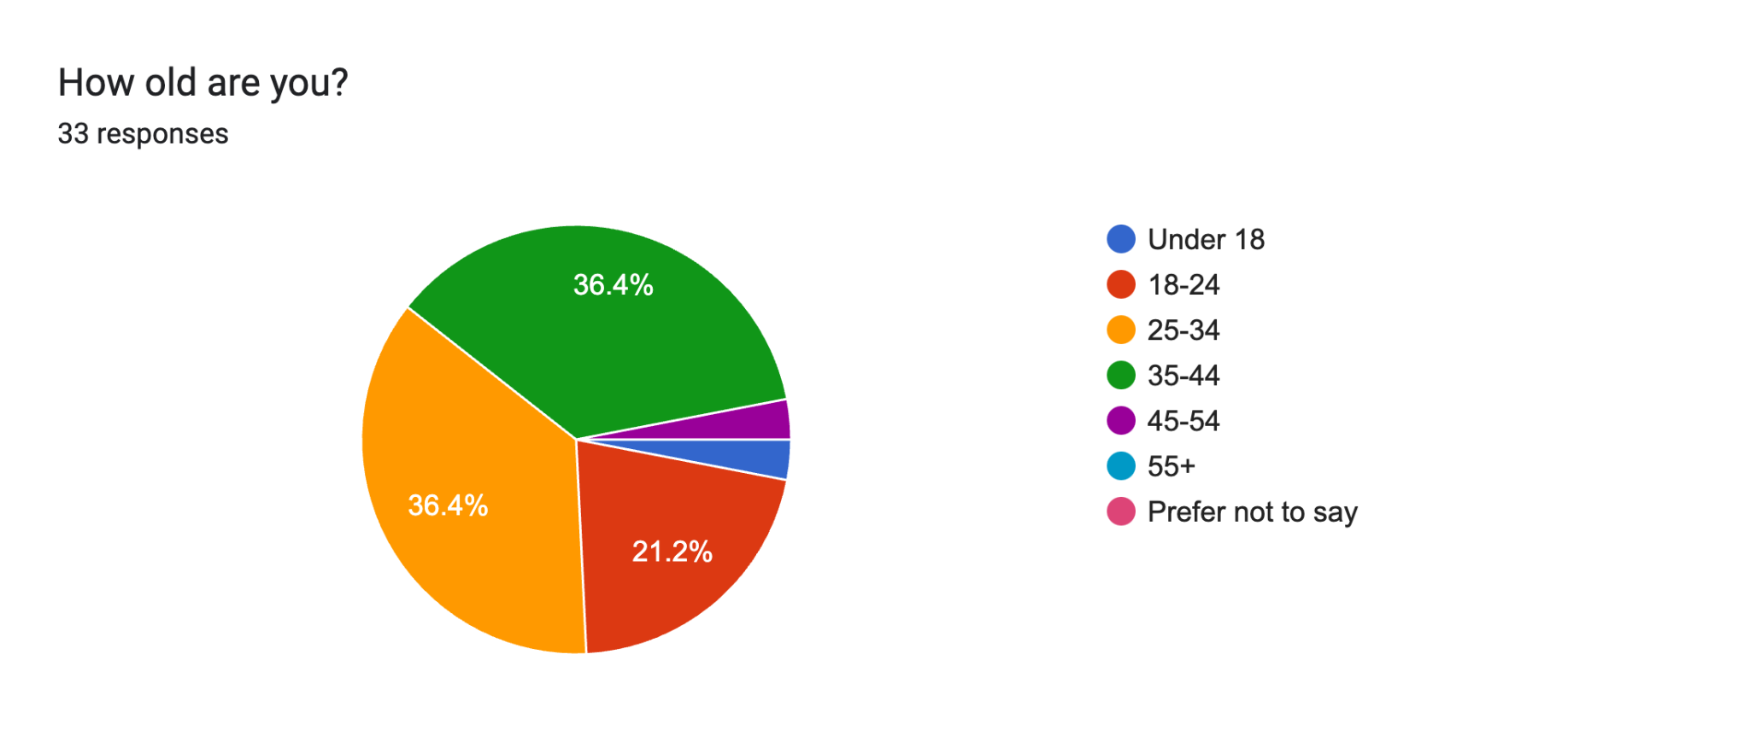

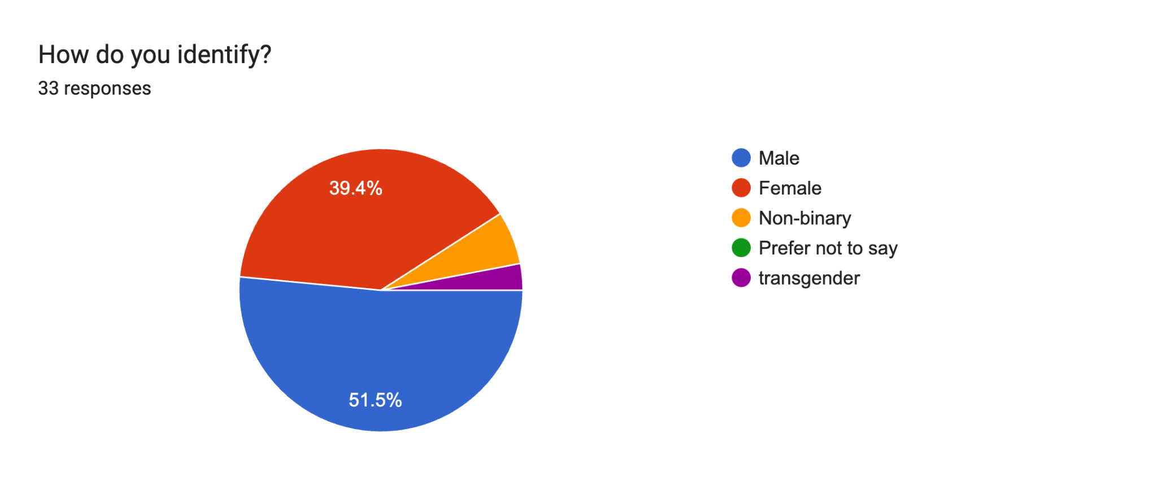

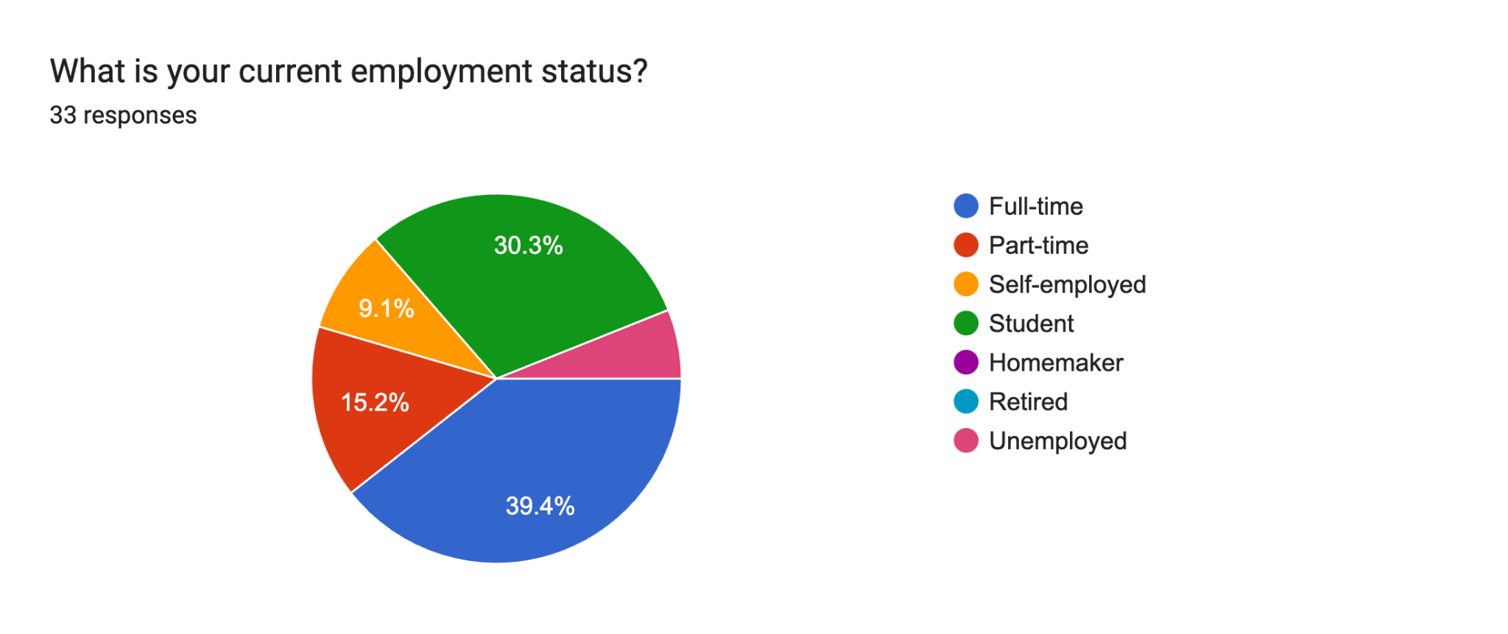

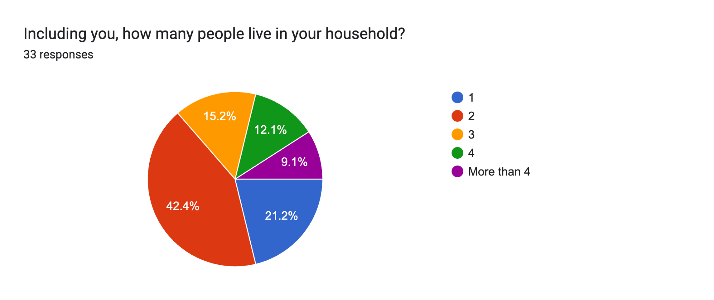

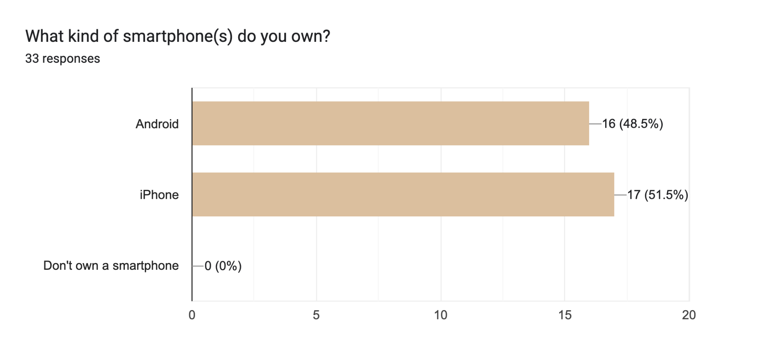

#### 

#### Demographics - Data at a Glance

* There were respondents from every age group except 55+, showing that games are played by participants of a wide age range.
* Participants of many identities play games.
* Participants of many employment statuses play games.
* Participants of many household statuses play games.
* Every participant owns a smartphone, all of which were Android or iPhone (there was a write-in option for “Other” which nobody used).

#### Demographics - Conclusions

Demographics didn't seem to have much impact, as participants from a broad range of demographic backgrounds reported that they play games. Participants are of varying ages, identities, employment statuses, and have varying numbers of people in their household. Therefore, demographics don’t have much bearing on our app at all.

#### 

#### Video Game Engagement - Results

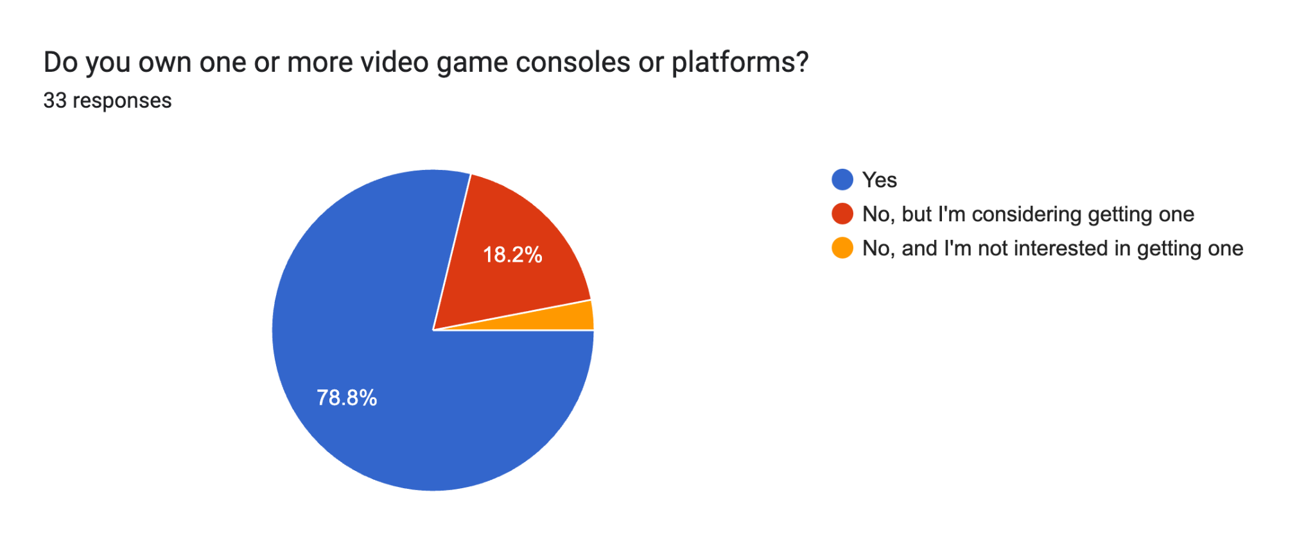

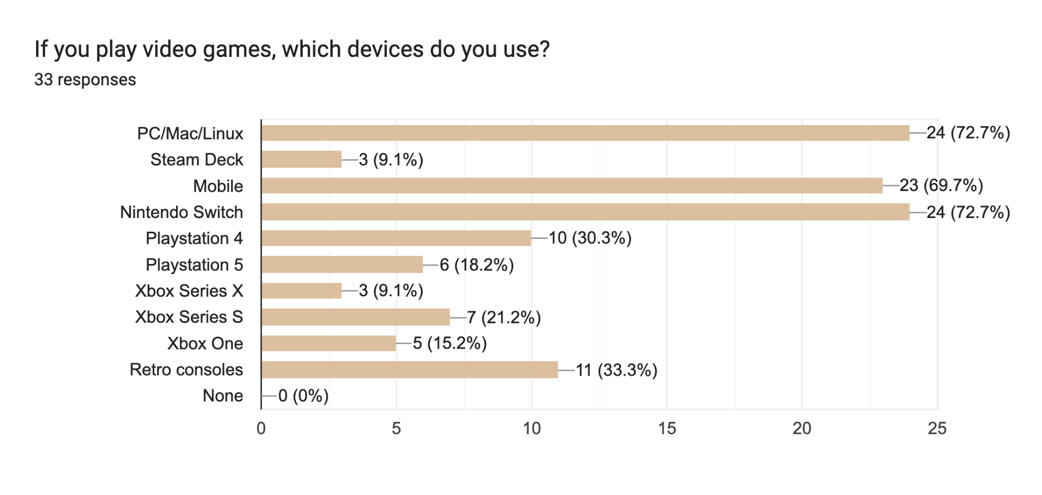

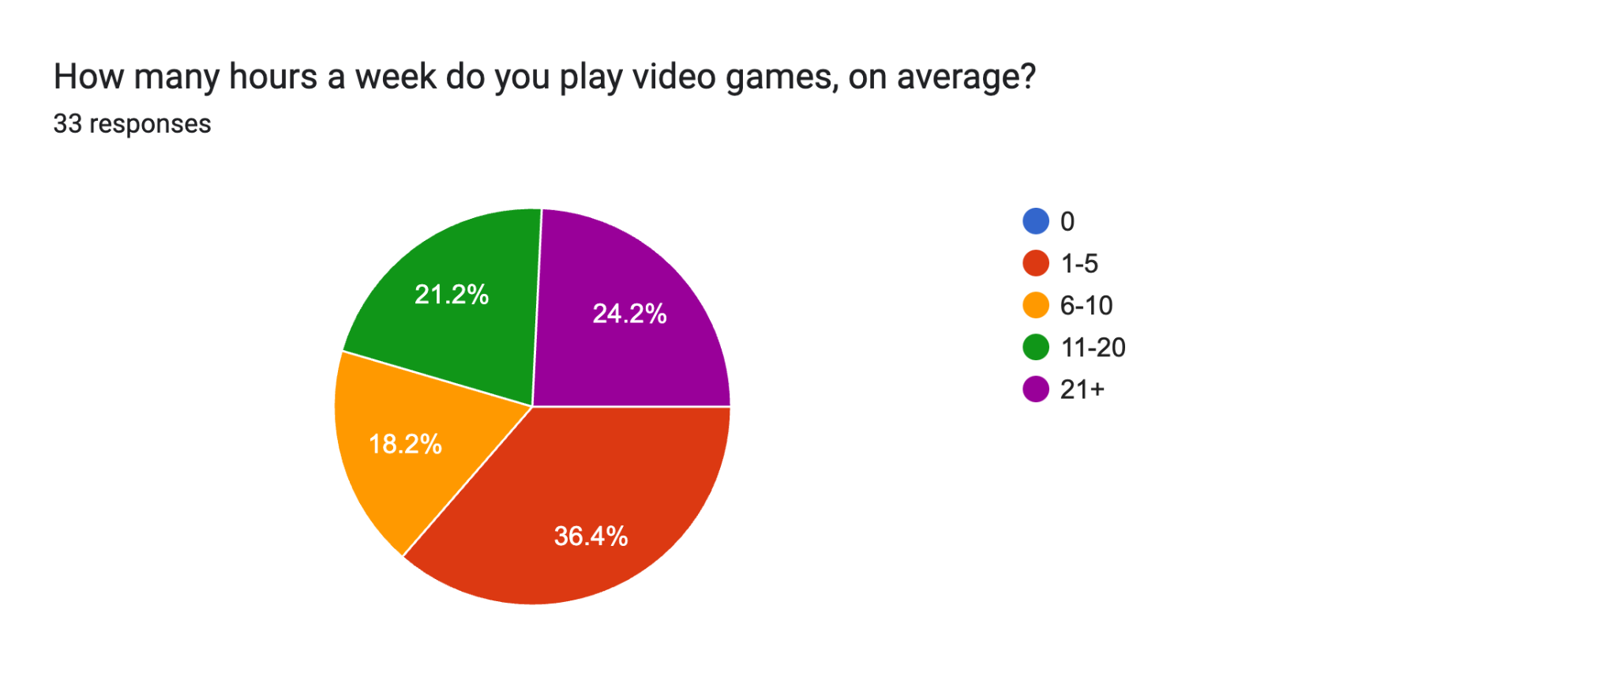

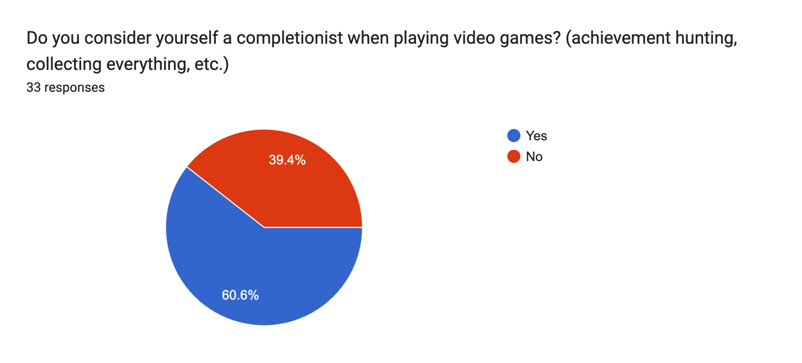

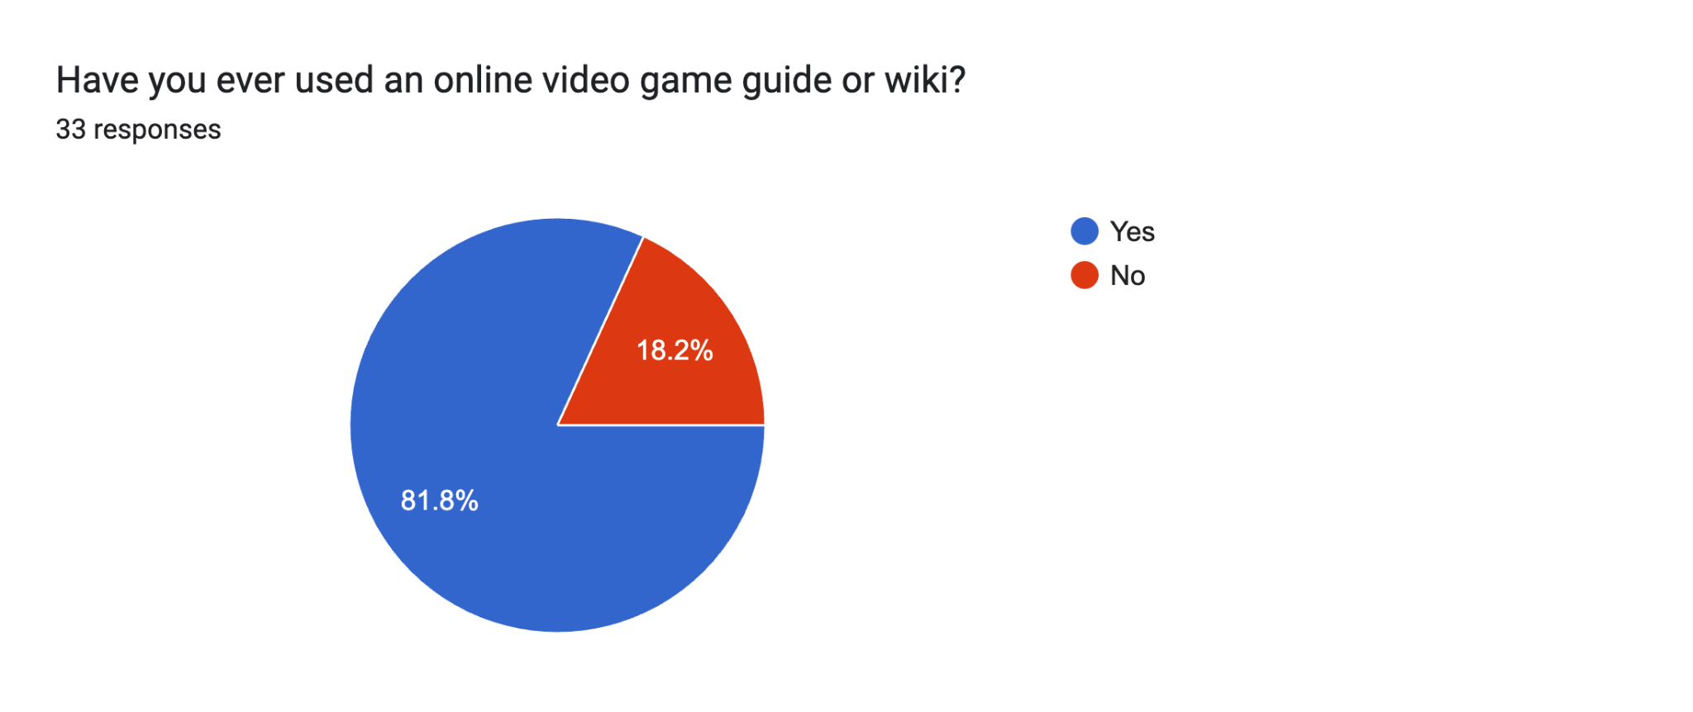

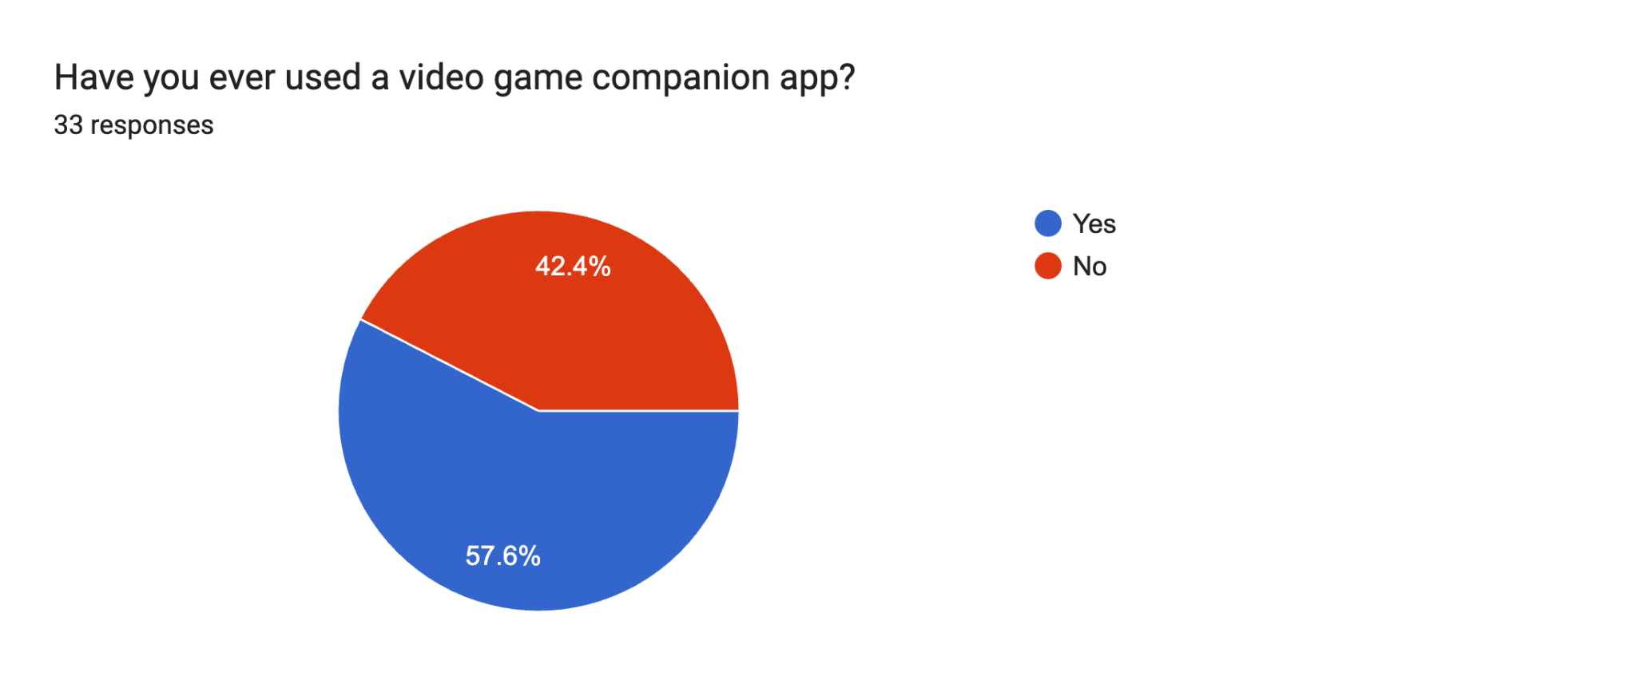

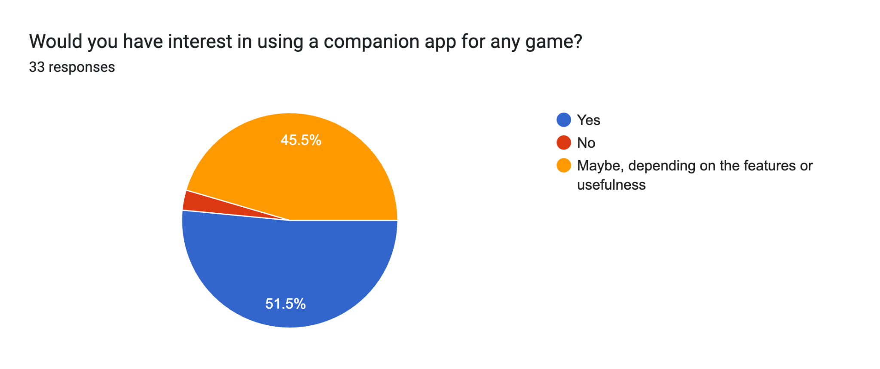

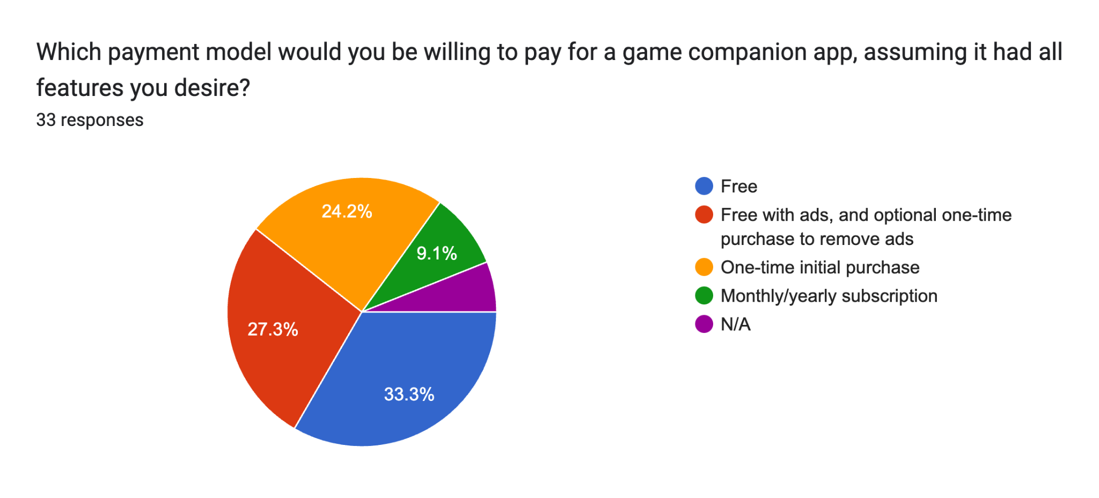

### Forms response chart. Question title: Considering your payment model chosen above, how much would you be willing to pay for a game companion app?. Number of responses: 33 responses.

### Forms response chart. Question title: Have you ever played Animal Crossing: New Horizons?. Number of responses: 33 responses.

#### Video Game Engagement - Data at a Glance

* 78.8% of participants own 1 or more consoles.
* 97% of participants own 1 or more consoles (or do not, but want a console).
* 72.7% of participants use a Nintendo Switch.
* 67.7% of participants play mobile games.
* All participants play video games for at least an hour a week, most respondents play games between 1-5 hours a week (36.4%) or 21+ hours a week (24.2%).
* The majority of participants consider themselves completionists (but not by much, 60.6% vs 39.4%).
* 81.8% of participants have used an online video game guide or wiki.
* 57.6% of participants have used a video game companion app.
* 51.5% of participants would be interested in using a companion app for any game, and an additional 45.5% would consider using them if they had good or useful features.  
  In total, 97% of participants would be open to using a companion app for any game
* Most participants would like the app to be free (33.3%) or free with ads (27.3%), for a total of 60.6%.
* 36.6% of participants would not be willing to pay for the app.

#### Video Game Engagement - Conclusions

Most participants surveyed do own a console and nearly every participant either owned a console or wanted one, with many owning a Nintendo Switch. Most participants either play games for a small period of weekly time (0-5 hours) or a significant amount of weekly time (21+ hours). This shows that we have a broad spectrum of gamers by time they spend gaming, so our app should be appropriate for gamers with a small amount of time as well as gamers who have a lot of time to spend.

Despite many participants identifying as completionists, 39.4% of participants did not. This means that our app should be appropriate for both completionists and casual gamers.

Most participants (81.8%) have used an online video game guide or wiki, which illustrates that there is a wide adoption of getting external resources on video games. Furthermore, 57.6% of those surveyed have already used a video game companion app, showing that this platform for game guidance is already adopted by a significant portion of our target audience, validating our use of an app as a game guide wiki.

Additionally, 97% of participants would be open to using a companion app for any game if they contain appropriate features. showing that we also have a wide prospective target audience for our product.

Regarding pricing, 60.6% of those surveyed would like the app to be free in some capacity (either completely free, or free with ads with an option to pay to remove them later). As a subset of this, 36.6% of participants would not be willing to pay for a companion app at all. This means that we should be careful in regard to our pricing strategy, and should incorporate an option that conforms to this.

#### 

#### AC:NH Companion App Interest - Results

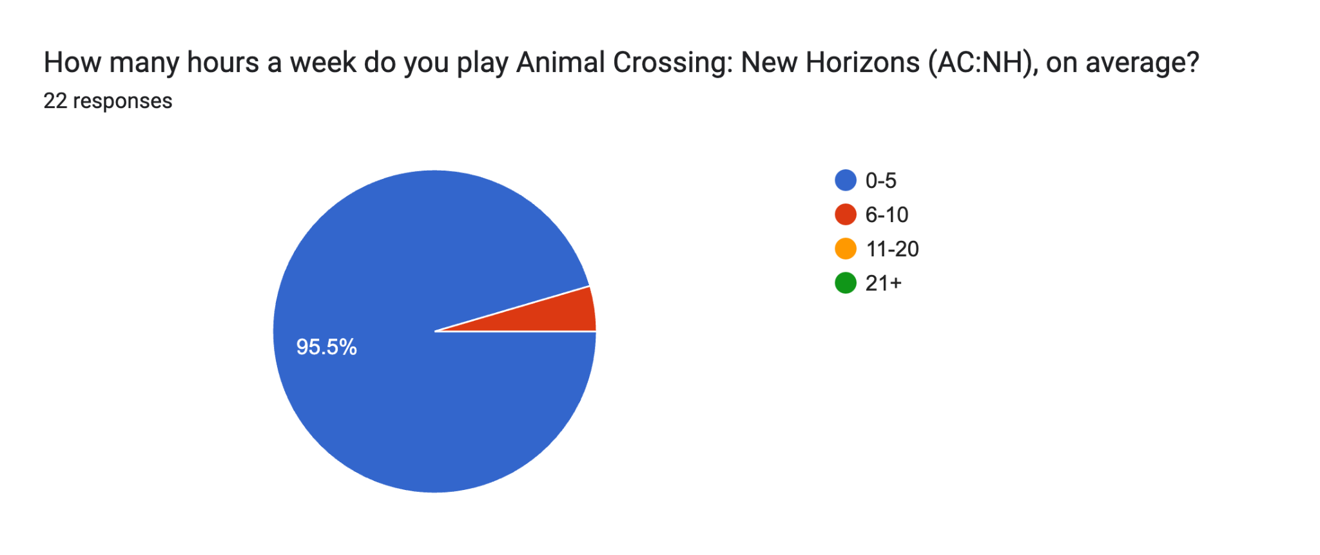

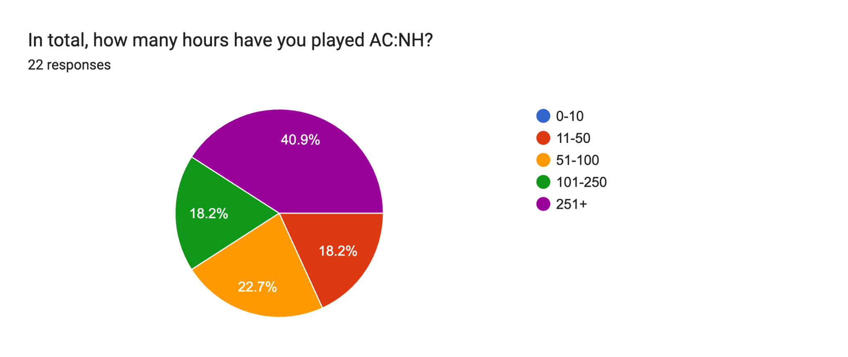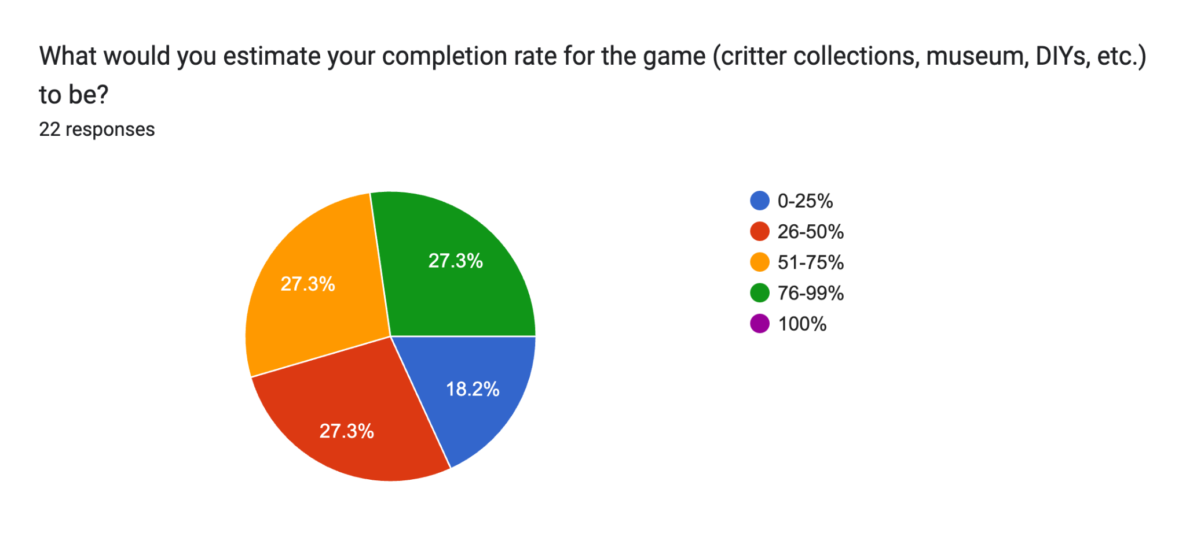

### Forms response chart. Question title: Have you ever used a companion app for AC:NH? . Number of responses: 22 responses.

### Forms response chart. Question title: If you have used a companion app for AC:NH, which app(s)? If not, answer "N/A" or "None".. Number of responses: 22 responses.Forms response chart. Question title: If you were to use a companion app for AC:NH, what kind of features would you want the app to include?. Number of responses: 22 responses.

We also asked participants to rank the top 3 features that they would like to see in a companion app for AC:NH. For this, we used weighted averages with the following coefficients and final overall rankings:

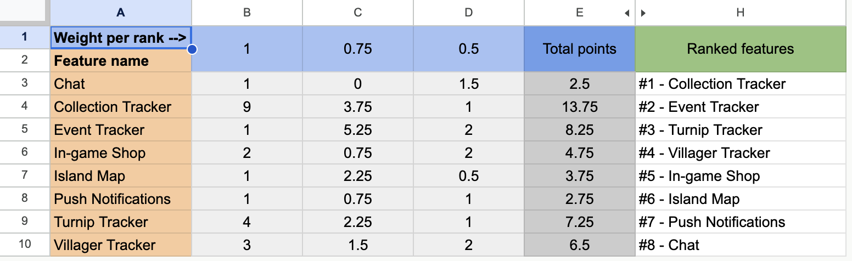

Data visualization took place to indicate the proportions of people who had selected a particular feature as their first, second or third choice:

### Forms response chart. Question title: Select the top 3 features you would like to see included in a companion app for AC:NH.. Number of responses: .

The rest of the key: 

#### 

#### AC:NH Companion App Interest - Data at a Glance

* 22 of 33 respondents play animal crossing.
* 95.5% of participants play AC:NH between 0-5 hours a week.
* 40.5% of participants have played it for over 251 hours.
* 27.3% of participants have estimated their completion rate to be either 26-50%, 51-75% and 76-99% (this is 27.3% for each mentioned category). 18.2% of people surveyed have only completed 0-25% of the game whilst no one has 100%ed it.
* 45.5% of participants have used a companion app for ACNH.
* 4 people surveyed used ACNH.Guide, and 2 people surveyed used ACNH Pocket Guide, Nookazon and the official app each.
* The most requested features were a collection tracker and event tracker (86.4% each) and a turnip price tracker (77.3%).
* The top 3 most prioritized features by weighted average were also a collection tracker, event tracker and turnip price tracker.

#### AC:NH Companion App Interest - Conclusions

Nearly all respondents (95.5%) play the game between 0-5 hours a week. This builds on the video game engagement survey as there is now a positive correlation between playing ACNH and being a gamer who only plays games a small number of hours a week. However, some participants may have stopped playing the game (as 0% is included). Despite this, a large number of participants have played the game for over 251 hours (40.5%).This may indicate that participants may have been playing it for a long time.

No one has completed the game in its entirety. This can mean that our app has some use for every user when it comes to complete game completion, especially as 60.6% of participants did consider themselves to be completionists.

This is further supported by our research showing that 45.5% of people surveyed have actually used a companion app for AC:NH. This demonstrates that there are indeed some target audience members who specifically play AC:NH, which formed the basis for our user personas. These participants used the official Nintendo Switch Online app (NookLink), ACNH.Guide, ACNH Pocket Guide, and Nookazon. Other than Nookazon, all of these apps were included in our competitor analysis.

Our app is using a red ocean strategy, as similar apps already exist as per our competitor analysis and the confirmation that our target audience members have already used most of these apps. This means that we can look deeper into the competitor analysis and user reviews to identify existing pain points for current users, as well as pain point solutions and positive feedback for the applications, so that our app can solve these pain points and provide desired features for the user.

To further investigate which features our target audience specifically would like, we also asked them which features they would want a companion app for AC:NH to utilize. Over half of the participants would like a collection tracker (86.4%), event tracker (86.4%), villager location/status tracker (63.6%), turnip price tracker (77.3%), the ability to order from the in-game catalog (68.2%), and push notifications for events (59.1%). Participants also expressed (to a lesser degree) interest in a dynamic island map, chatting with other players, and custom designs. This means we should add the most requested features at a minimum, and, if feasible, include all requested features to satisfy our target audience as much as possible.

To obtain some more specific quantitative data on the most prioritized features, we asked participants for their top 3 features they would like to see in an AC:NH companion app. From our weighted averages, we found the most important feature to be a collection tracker, followed by an event tracker, and finally a turnip price tracker taking the third spot. All of the existing apps apart from the NSOnline app do possess both a collection tracker and event tracker. A turnip price tracker was not considered in our initial competitor analysis, so this can be investigated further. From this feedback, we should definitely include these 3 top features to meet the needs of our target audience.

### 

### Survey - Final Summary

Our survey data enabled us to quantify some user wants and needs which we satisfy with our app concept design. Of these insights, there are a few things that we should give consideration to in regard to the design phase of the design process.

These considerations are as follows:

* Demographics did not play a significant role in determining whether a participant plays video games.
* Participants who played games mostly played them for a short time (0-5 hours per week), or a long time (21+ hours).
* A close proportion of participants self-identify as completionist or casual gamers.
* A large majority of participants have used a game companion app or wiki and an overwhelming majority of users would be open to using a game companion app if the features aligned with their needs and provided solutions to their pain points.
* Most participants would like the app to be free entirely or with ads.

This data validates that our gaming companion app would be useful for gamers as long as it meets their needs. Additionally, with this data, we should consider catering to those who play games for a long and short time, as well as those who are completionists and casual gamers. Finally, we should keep our current pricing strategy, as most users surveyed want a free tier.

For the AC:NH players, the main points of discovery were the following:

* An overwhelming majority of participants play the game between 0-5 hours a week.
* Just under half of the participants have used a companion app for the game before.
* Over half of the participants desired to have a collection tracker, villager location/status tracker, event tracker, turnip price tracker, the ability to order from the in-game catalog, and push notifications for events.
* The top 3 most requested features were a collection tracker, event tracker, and a turnip price tracker.

This data validates our concept further, as individuals have previously used companion apps for gaming, indicating that they likely met some of their pain points with the game. We should also consider including all of the features that over half the participants desired: the collection tracker, villager location/status tracker, event tracker, turnip price tracker, the ability to order from the in-game catalog, and push notifications for events. We should also emphasize the usability of the top 3 features to meet most of the users’ needs. We should, however, not neglect other less-popular features and should research these further.

### Interview - Analysis

**Summaries of participant responses can be found in Appendix B.**

We obtained a large volume of quantitative data via our survey, which enabled us to quantify some specific user needs as well as some demographic and psychographic data. We also needed to understand more about our participants’ motivations and feelings towards our product via obtaining some qualitative data. Therefore, interviews were conducted.

One interview participant has now stopped playing the game due to having an abundance of the in-game currency, bells, meanwhile the other only plays it from time to time. This could indicate that people interviewed may have just lost interest in the game itself.

Regarding the collection system, one user found that the collection system took a long time because they didn’t know how or when to catch the fish. This indicates a pain point that our app could provide a solution for by providing details of when to catch or collect certain items as well as details on how to use some of the controls. The other user did not like waiting for specific seasons to get the collectibles they need. Unfortunately, this is due to the design of the game, and therefore creating a solution to this pain point with our app is not really feasible. What can be inferred from this data is that we have participants who do not know what to catch during which season, as well as participants who do.

Both participants have similar gameplay times on the game with 145 and 150 hours respectively, indicating that both participants have played the game for a significant amount of time. Despite being quantitative data in an interview, this gives us useful data to contextualize the responses being from participants who have played AC:NH for a considerable amount of time.

One participant described themselves as a completionist, while the other identifies as a casual gamer. This aligns with our survey data, where 60.6% identified as completionists compared to 39.4% identifying as more casual. This reinforces the conclusion that we should consider both completionists and casual players when designing our app. Both the completionist and the casual player could each be included in our user personas, to indicate how each type of gamer may be motivated to use our app.

In regard to our app concept, interview participants had several opinions. To quote one participant, “It would be helpful to be able to see information about the game without having to log in to the game. Sometimes you open the game just to check if anything interesting is going on and find out nothing is, but an app that could tell you about your game could waste less time.” However, the other user stated “I like the idea and it would make me play ACNH more by notifying me about what’s going on.” The notion that can be inferred from the interviewees is that they both have some interest in our concept. Both interviewees liked the idea of getting notifications about what is going on in the game, with one participant identifying an existing pain point of having to open the game to simply check if anything interesting is going on. The other participant also agreed with this, even stating that being notified about in-game events would motivate them to play the game even more. This also corroborates our survey data, where the event tracker was tied with the collection tracker for the most requested feature for an AC:NH companion app. This means that we should implement this feature in our app, which will satisfy the needs of many members of our target audience. One participant mentioned a pain point of having to open the game to simply check for any interesting content (which includes events). The other participant mentioned that they would play the game more frequently with event notifications, which is a potential solution to this pain point.

Participants were also informed about all of the features we are intending to implement in our concept, and there were favorable comments on event tracking, villager tracking, shopping from your phone, and turnip tracking. This also aligns with what was uncovered during our survey, with the event and turnip tracker being in the top 3 requested features, as well as the shopping feature and villager tracker also being desired (68.2% and 63.6% of participants, respectively). We should therefore definitely include the event and turnip trackers, as our data from both the survey and interview emphasizes the importance of this as a user desire from our app. There were negative comments on our proposed features, such as the chat feature being unnecessary, which our survey data did support to some extent, with only 31.8% of users surveyed wanting a chat feature included. This means that this feature should not be a priority to include; however, over a third of survey participants do want this feature, so it should not be dismissed completely.

Regarding additional features from our planned features list, the only additional feature mentioned was actually another pain point and solution mentioned by a participant who would “like to see a custom pattern browser that’s more robust than the in-game one to be able to search, filter, and load new patterns.” One participant did suggest this in our survey, though it is possible that this is the same user. Regardless, we should consider this as a possible feature.

We also decided to ask the interview participants to walk us through their personal use case scenarios for our concept, wherein both participants mentioned checking turnip prices. This further emphasizes that this feature should be included in our app concept given our survey data and previous interview questions corroborating this as a user need for our product. Other use cases also included checking the app for events to see if there's “anything interesting going on.” This corroborates our survey data which found that users placed an event tracker in their top 3 most prioritized features, as well as 86.4% of users wanting this feature included without the restriction of being limited to 3 features.

An interviewee also mentioned their use case for the app as “finding out where the villagers are and which villagers are visiting the island with the purpose of acquiring them.” When thinking about the villager system, we were considering aspects such as their positioning on the map. However, seeing which villagers are on the island to acquire them discovers another pain point and solution. The pain point, again, is that you need to open the actual game and walk to the campsite to see who is visiting you, and the solution is including functionality to be able to see visiting villagers. We should definitely add the villager tracker as a feature. Our survey data already confirmed that many participants would like a villager tracker (63.6%), and one interviewee mentioned they liked villager tracking in our concept.

Our final question pertained to getting the interviewees’ thoughts on our intended pricing strategy, which is to make the app free with an optional $3-4 purchase to remove ads. One interviewer mentioned that they only find the price point acceptable because it has a free tier, and would not pay to remove the ads whilst the other participant mentioned that the price to remove ads seemed reasonable and that they would be willing to pay to remove the ads to support the developers if the app improves their quality of life. This also aligns with our survey data where 60.6% of participants would like the app to be free in some capacity, whether that be completely free (33.3%) or free with ads and a paid option to remove them (27.3%). Most other participants would be happy to pay in some capacity for the app. Therefore, we believe that we should maintain the current projected pricing strategy, as this satisfies most users’ needs.

### 

### Interview - Final Summary

The purpose of the interviews was to understand individual user needs, which could then go on to inspire our user personas. From the data from the interviews, we also discovered motivations for using our app, pain points with the game and existing apps, and we were able to confirm some of our conclusions from the quantitative analysis.

User motivations for using our app that were discovered are as follows:

* Saving time (due to the process of having to enter the game to check basic information).
* Finding out which collectibles are available during a season.
* Finding out which villagers are at the campsite.
* Checking turnip prices.

Several user pain points were discovered:

* The game controls are not easy to find.
* There is no information in-game about which season each item can be collected during.
* A player has to log in to the game just to see which events are going on and which villagers are visiting the campsite.
* The in-game custom pattern browser is not robust and difficult to use effectively.

Given these conclusions, we should provide solutions for all of these pain points.

In addition to these conclusions about user attitudes, some of the conclusions drawn from the survey data were reinforced by our interview data. For instance, the two interviewees identified differently as a completionist or a casual gamer, emphasizing that our app should cater to both types of gamer. Furthermore, the interviewed participants liked most of the proposed features of our app. To summarize, we should incorporate the following for our app:

* Our pricing strategy should be maintained.
* We should include the following features: event tracking, villager tracking, shopping from your phone, and turnip tracking. These were also desired by participants in the survey.
* We should conduct further research to determine if we should add a custom pattern browser. There was only 1 survey participant and 1 interviewee who asked for this feature, but it was not on our initial plan for the app. This can be investigated further by revisiting our competitor analysis to see if any other apps have this feature to either draw inspiration for the implementation or exploit a niche to draw more potential users to our app.

## 

### Data Analysis - Conclusion

To conclude, we believe that we did meet the intended goals of our research. We obtained both quantitative and qualitative data about our target audience. We also validated which features potential users want included in the app, as well as additional features that were not included in our initial design that our participants would like to see us implement. We have also uncovered user pain points with both our competitive analysis and our user interviews, as well as possible solutions to these pain points. We did also confirm that our app concept is valid from our research, due to participants having used companion apps made specifically for AC:NH, with nearly all of the used apps having been a part of our competitive analysis.

Overall, we did not only prove our initial concept ideas via our quantitative and qualitative research and analysis, but we also obtained valuable data on how to improve our concept to provide solutions to uncovered pain points with the aim of optimizing the following steps of the design process. Ideally, we would like to iterate through this analysis process after we conduct user testing on a prototype of our concept to iteratively improve our user experience (as the design process itself is iterative).

Finally, this analysis has served as the basis for our profiling, firstly by inspiring user personas, with us having created personas that represent both a completionist and a casual gamer (as we discovered both types were strongly represented in both types of research). Our research also inspired our user scenario map and user storyboard, as we uncovered features that most potential users would utilize, and how users would use our app in general.

## 

## Part 2 - Define User Profiling

### User Personas

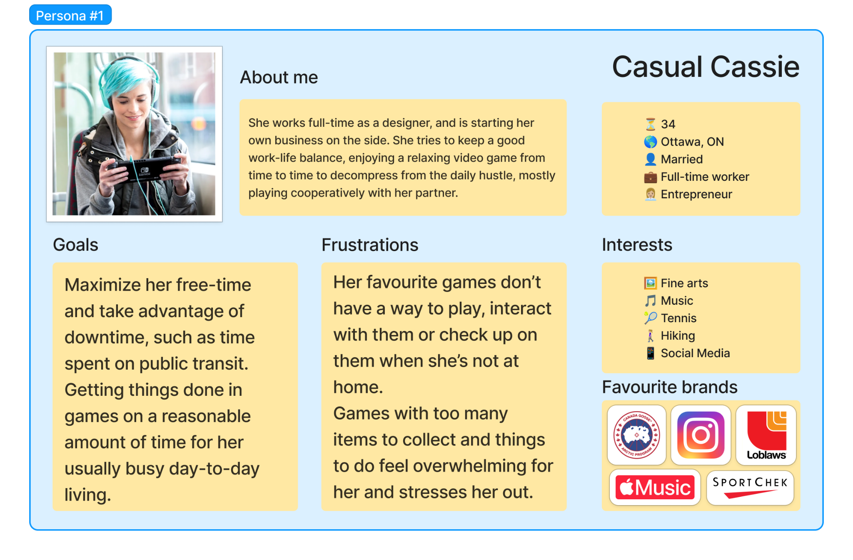

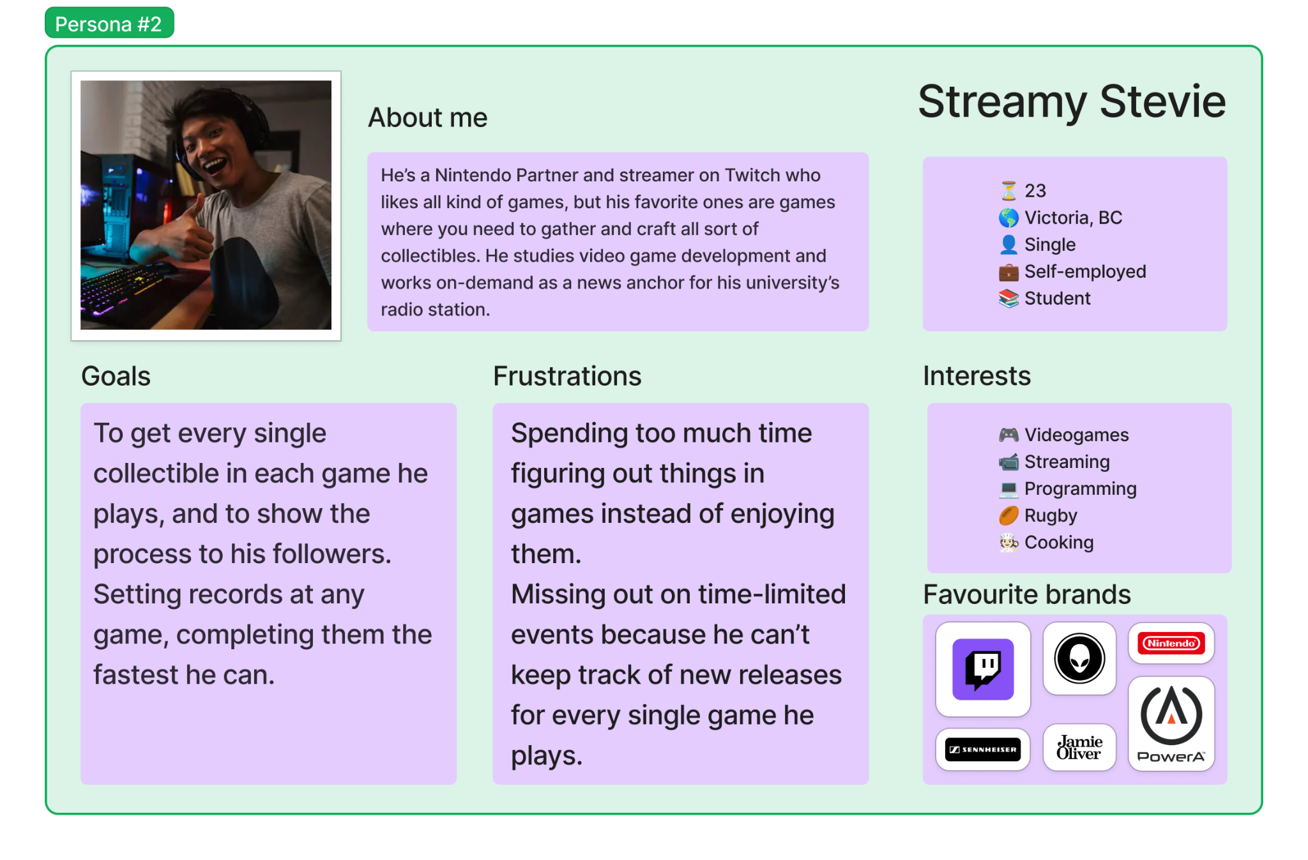

### User Scenario Map

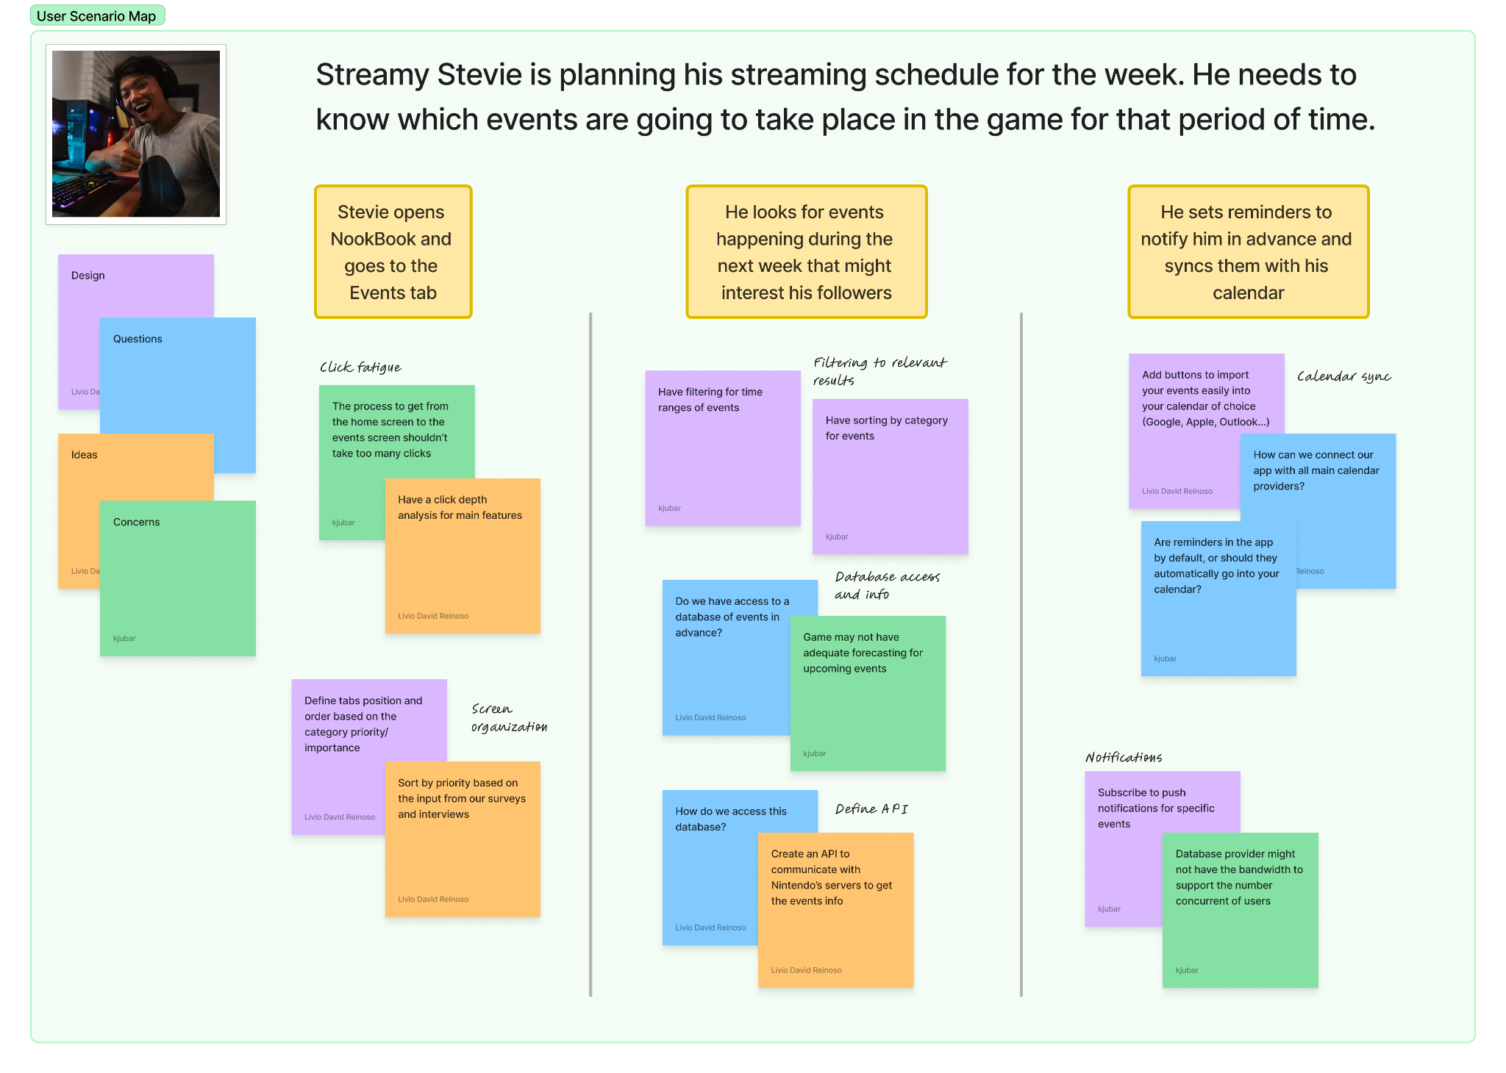

### User Storyboard

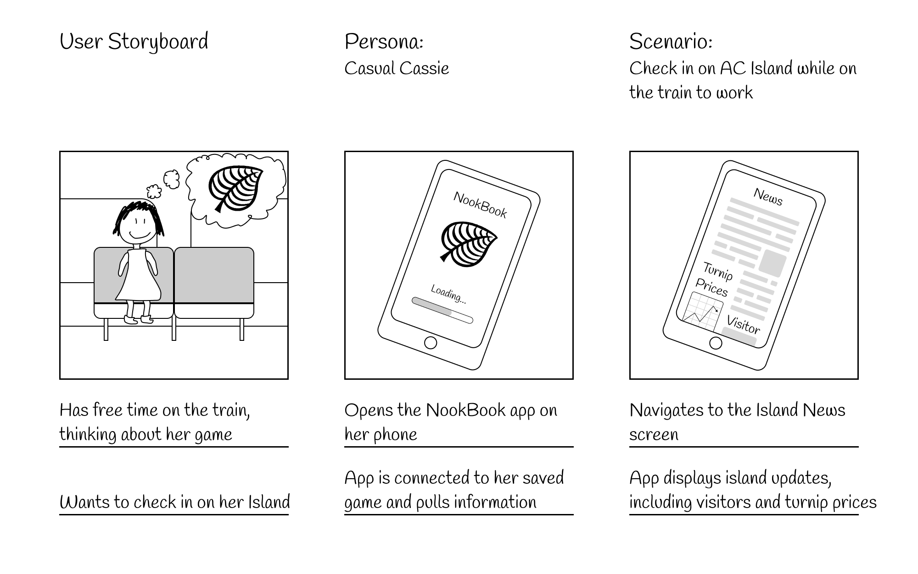

## Part 3 - Mood Board

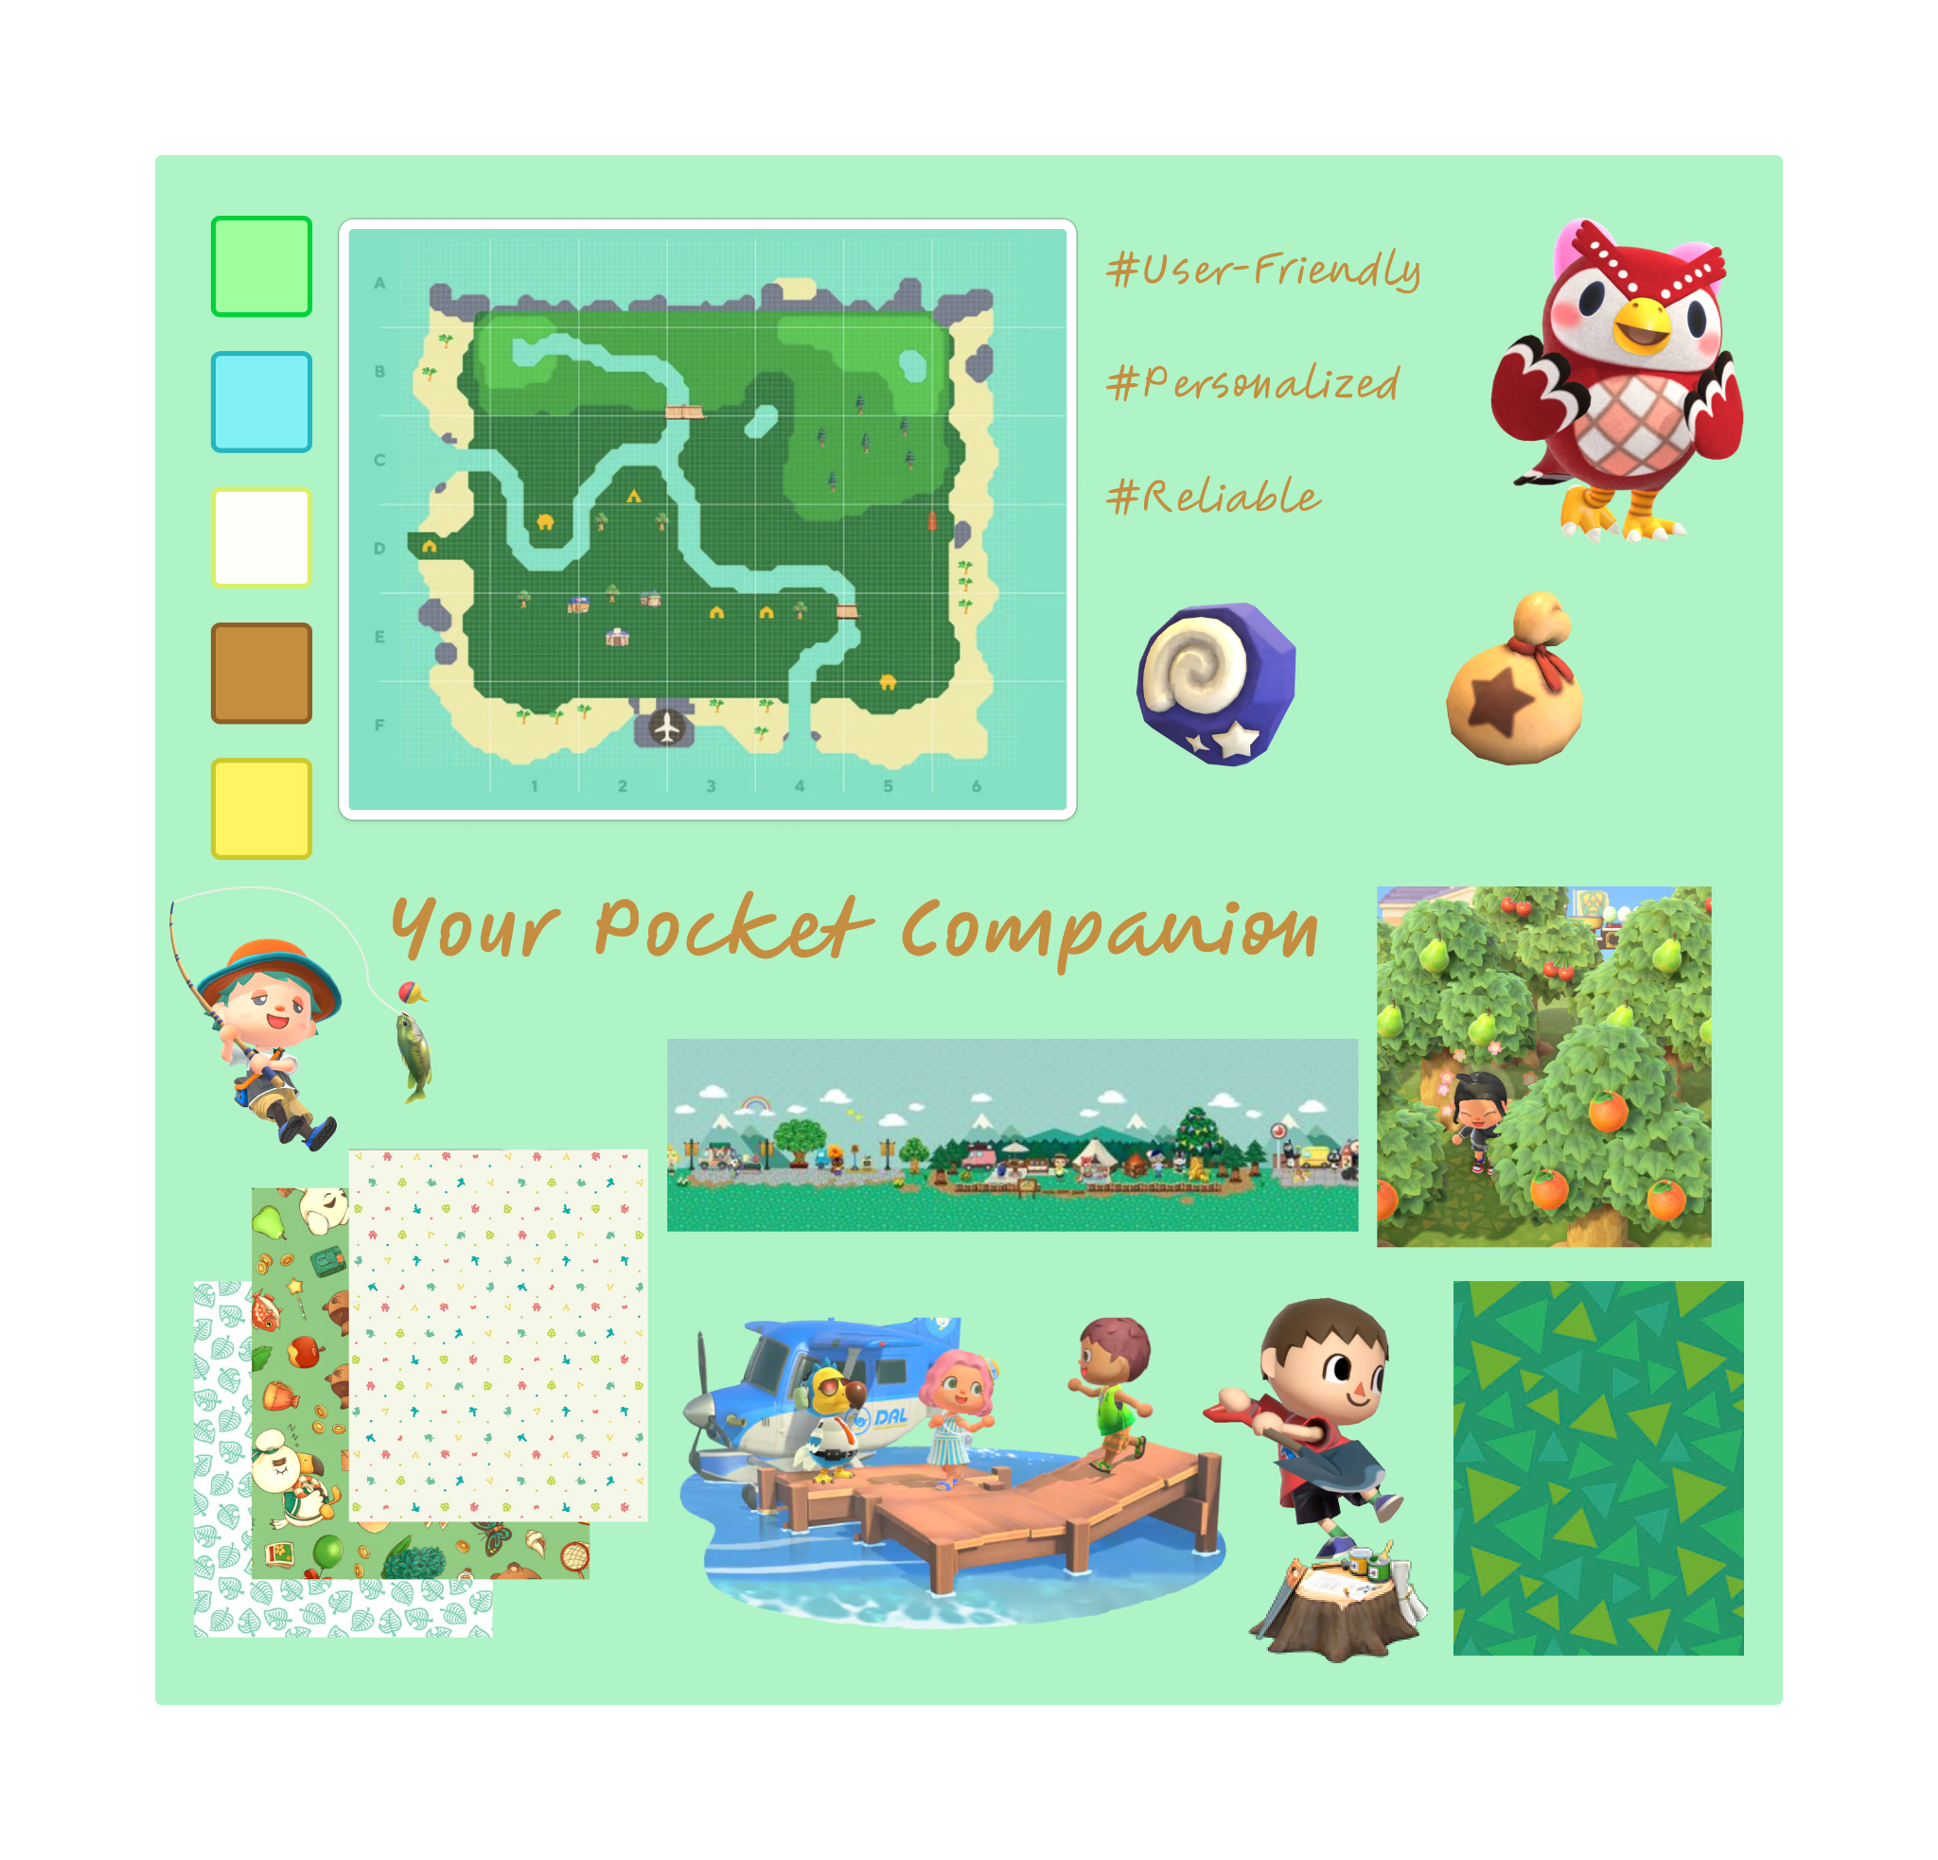

## Part 4 - Pick a Name!

We have decided to call the app NookBook, a play on “notebook” with a reference to Animal Crossing - Tom Nook is a tanuki entrepreneur who appears in all entries in the Animal Crossing series, and plays a critical role in the player’s game.

# Project Check-in 3 (P-3)

## Part 1 - User Flows

### User Flow 1 - Livio Reinoso

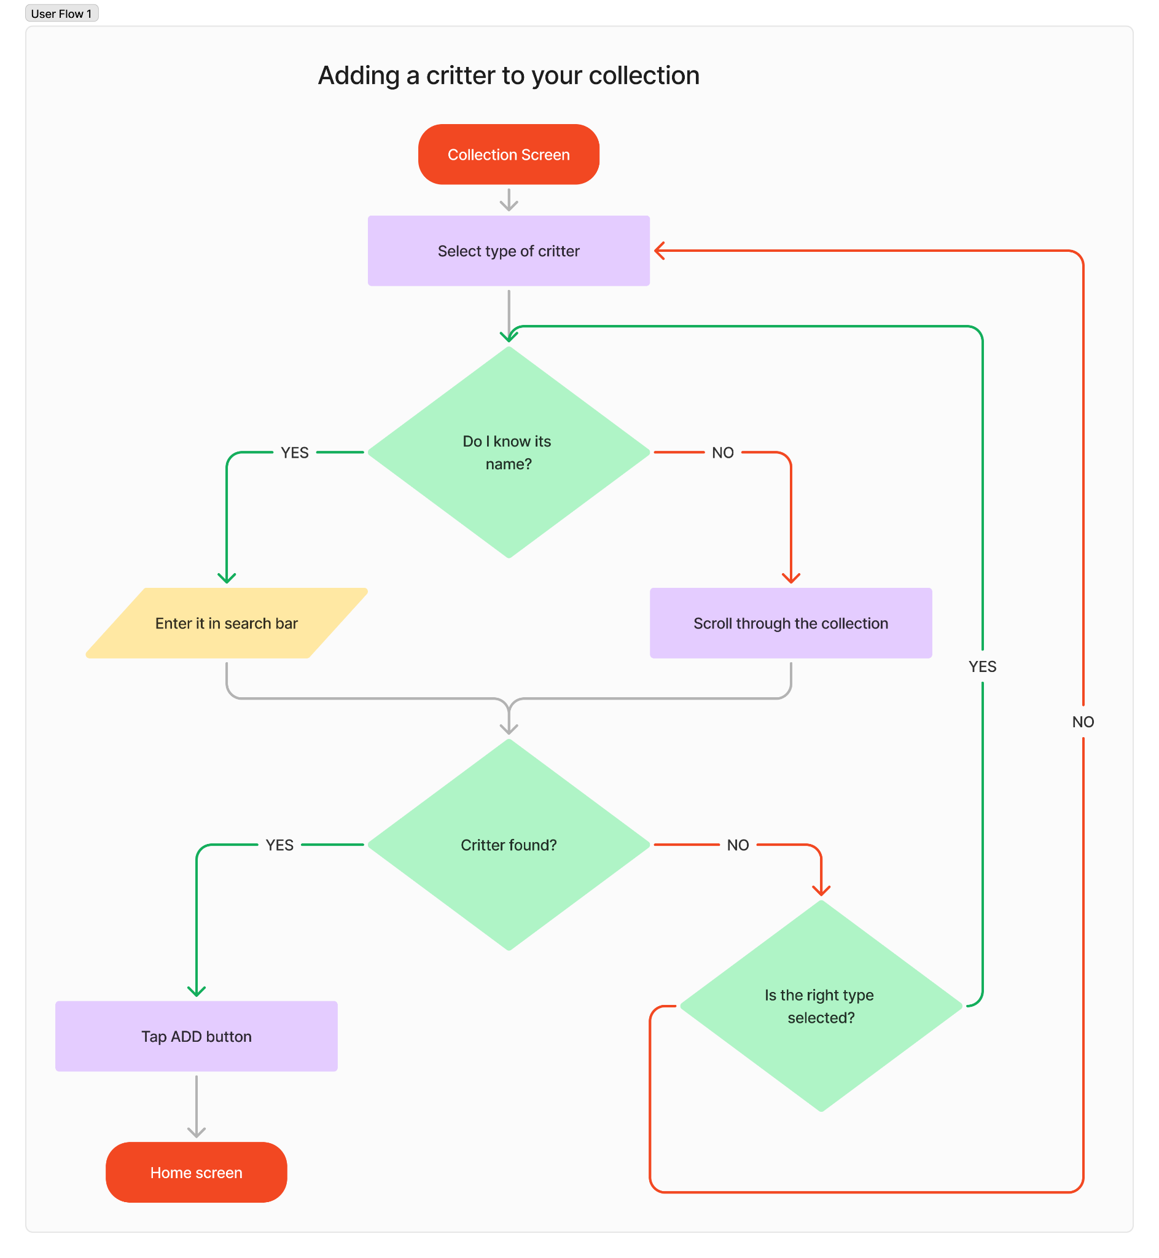

### User Flow 2 - Kaleb Jubar

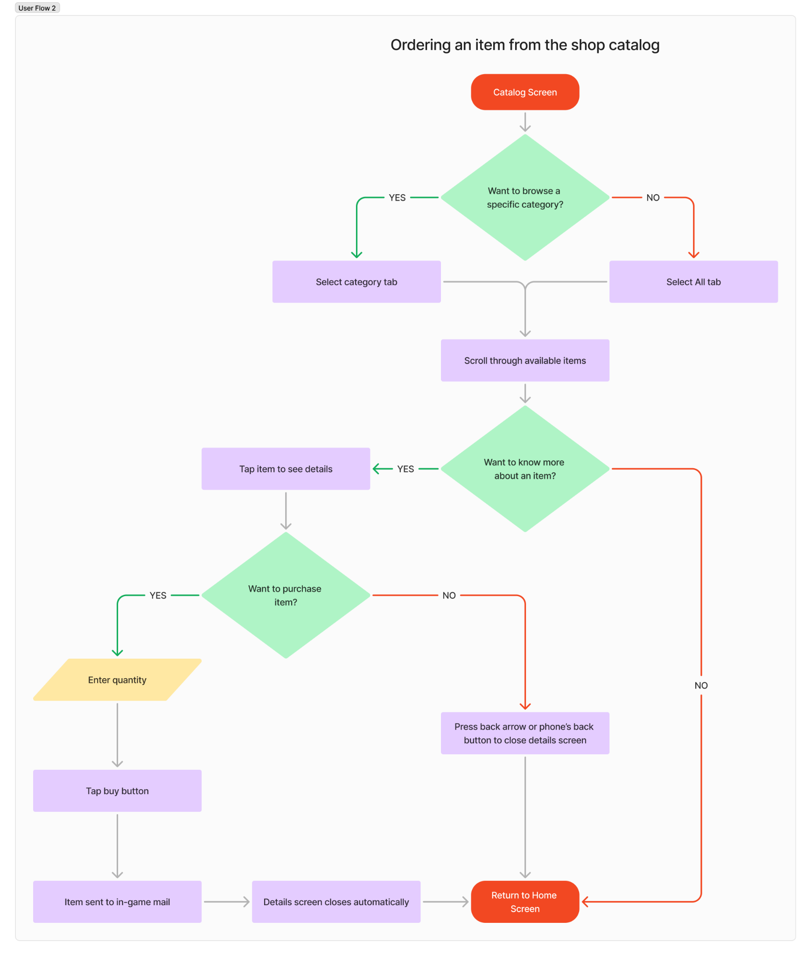

### User Flow 3 - Aggrey Nhiwatiwa

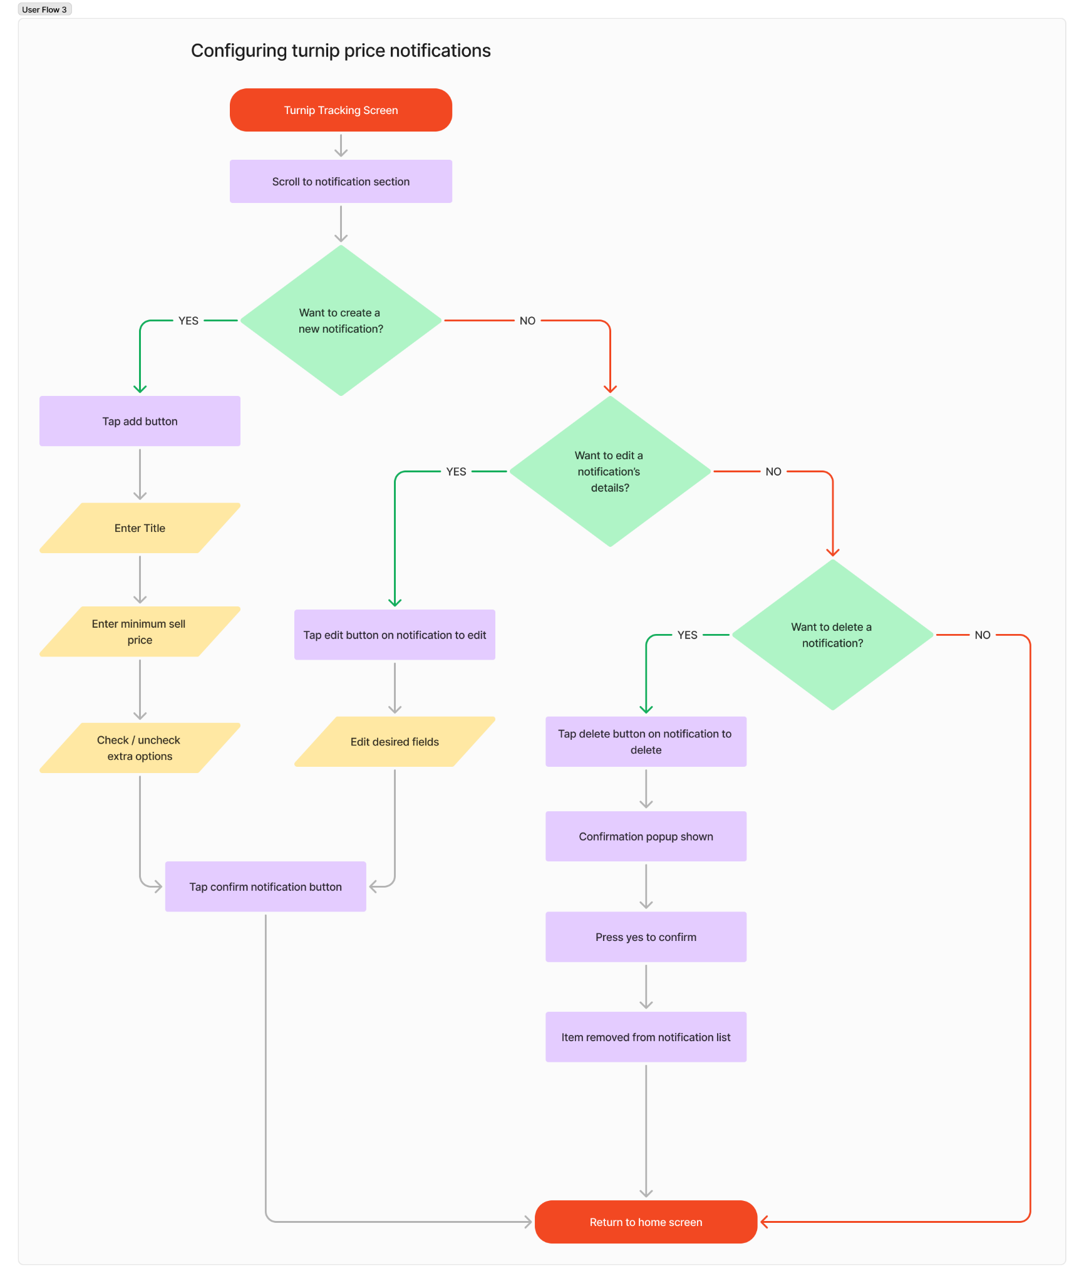

### User Flow 4 - Samet Berk Özdemir

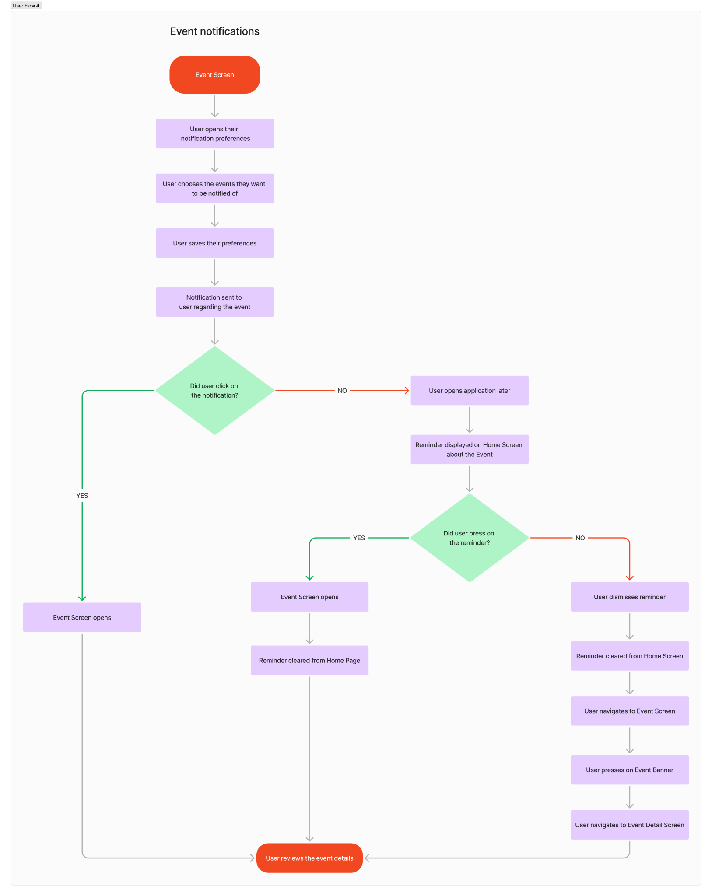

## Part 2 - Low-Fidelity Wireframes

### Wireframe 1 - Adding a critter to your collection - Livio Reinoso

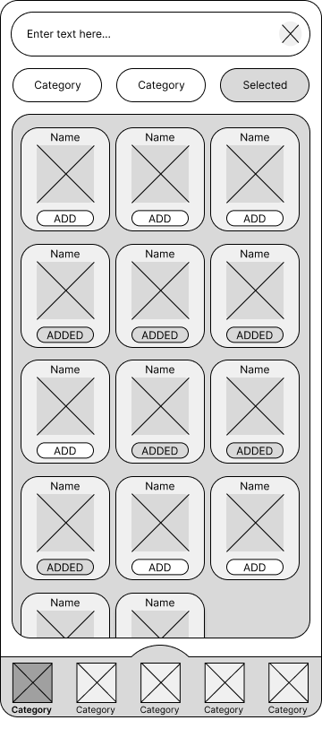

### 

### Wireframe 2 - Ordering an item from the shop catalog - Kaleb Jubar

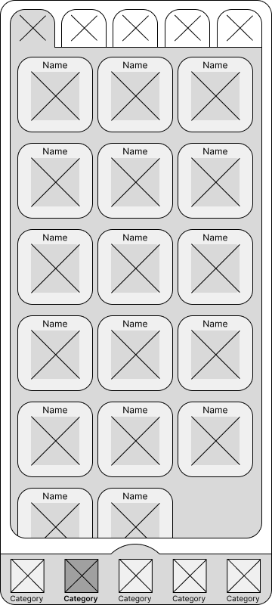 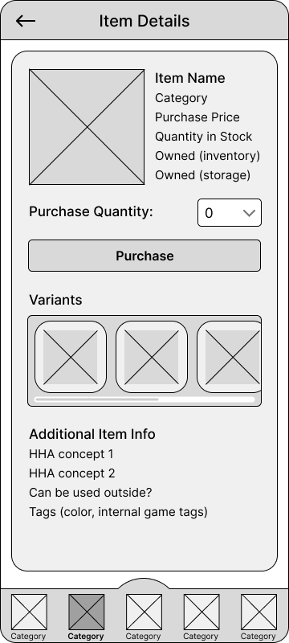

### 

### Wireframe 3 - Configuring turnip price notifications - Aggrey Nhiwatiwa

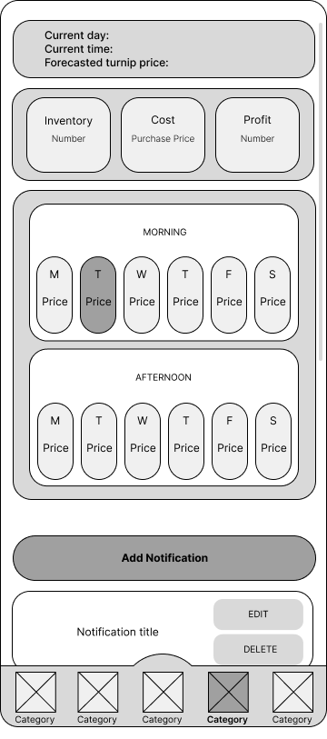 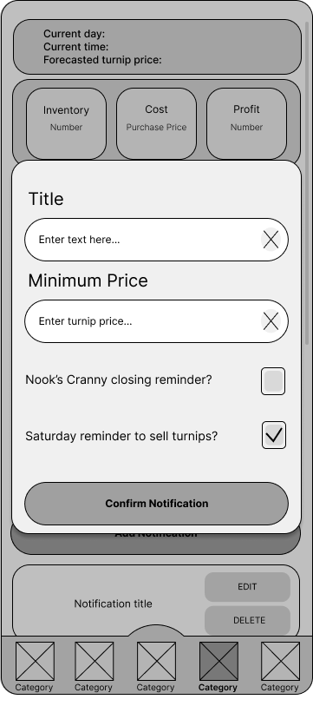

### 

### Wireframe 4 - Event notifications - Samet Berk Özdemir

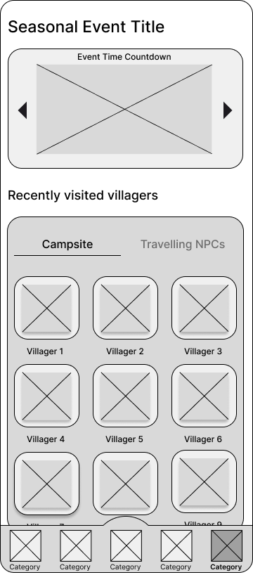 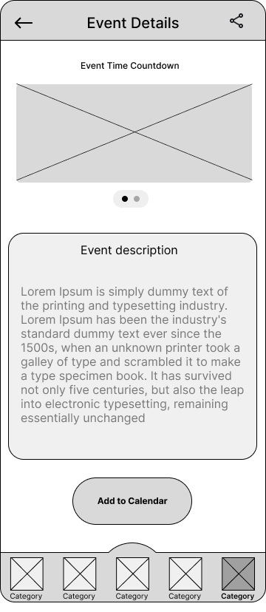

# Final Project Check-in (P-4)

## Part 1 - Style Guide

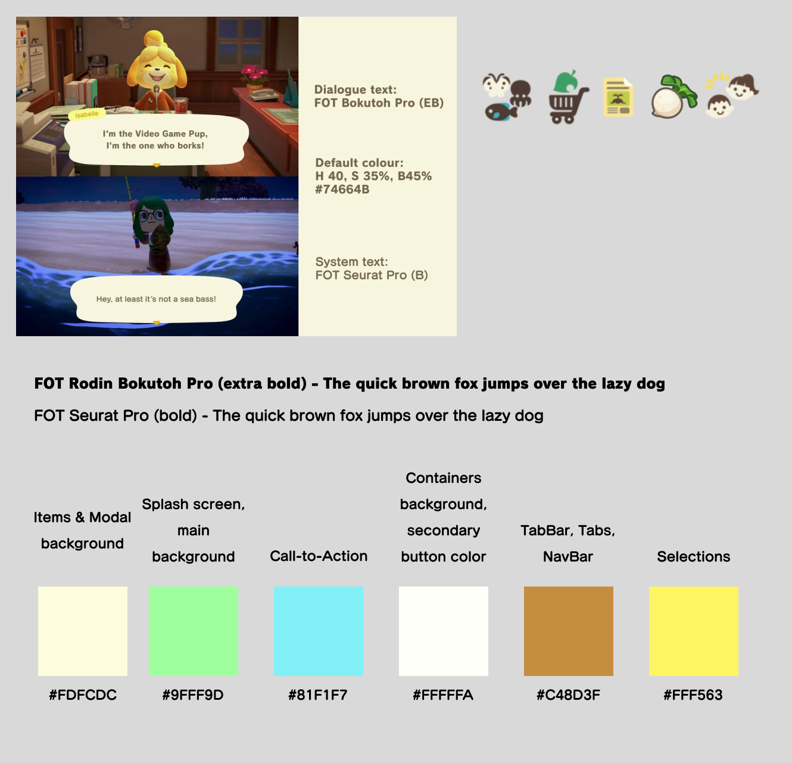

## Part 2 - Prototype

Our prototype was made with Figma, using the wireframes from P-3 as a base. Prototype link:

<https://www.figma.com/proto/GfMMzmGvD2O18r7sQchtGD/UI%2FUX-Project-check-in-4-prototype?node-id=2008-1440&t=R7C0suOsjoywRfL6-0&scaling=scale-down&content-scaling=fixed&page-id=0%3A1&starting-point-node-id=2091%3A1788>

## Part 3 - User Testing

### **Item Shop - Kaleb**

#### Test Users

1. Early 30s (F), gamer, ACNH player, on Windows w/ Chrome.
2. Mid 30s (F), gamer, ACNH player, on Windows w/ Chrome.
3. Early 40s (M), gamer, not an ACNH player, on Windows w/ Chrome.
4. Mid 30s (F), gamer, ACNH player (limited experience), on Windows w/ Chrome.
5. Mid 40s (M), gamer, ACNH player, on Windows w/ Chrome.
6. Mid 30s (M), gamer, ACNH player (limited experience), on Windows w/ Chrome.

#### A/B Testing

Tested a **different order in layout** of the item details and purchase button on the item detail screen. The first variant has the Purchase button immediately below the item’s picture and price, while the second variant has the Purchase button at the bottom of the screen.

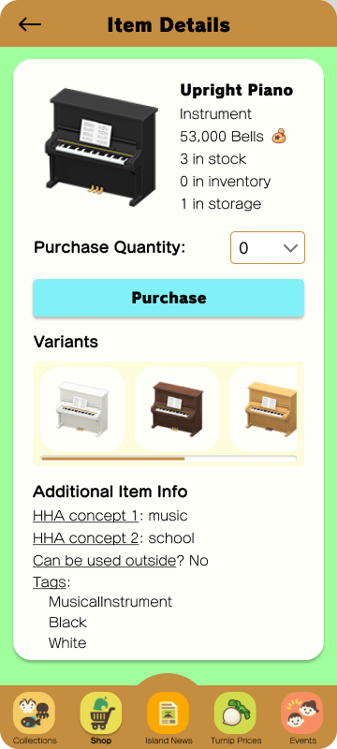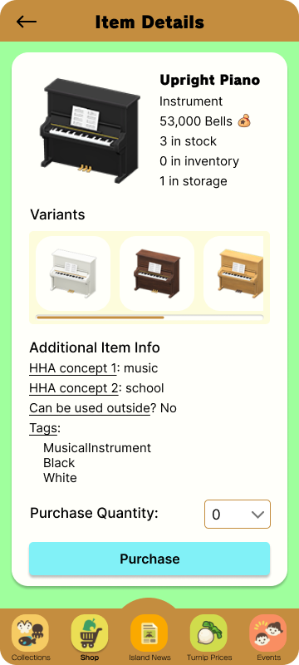

Screen A Screen B

##### Results

When choosing between the 2 options provided, the participants unanimously chose the second option. The justification given by all of them aligned with preferring to read all of the details and information about an item before purchasing. Some participants (1, 3, 6) suggested that their impulse would be to purchase without reading the other details, while the rest stated that they would read through all of the details anyways but the purchase button being in the middle would break up the flow and make it annoying to read. One participant (4) suggested an alternate option after some discussion - placing the purchase button under the variants list but before the additional details, as the extra info might not be something everyone is interested in reading.

The key takeaway from this test is that the purchase button should be moved further down the page, with most people preferring having it at the bottom under all information. We could also conduct further testing with the suggestion from participant 4 to determine if that layout would suit users better.

#### Usability Test

Starting from the Home screen, users were required to **purchase an upright piano** to determine how intuitive the app is for users who have never interacted with the app before. The steps required to complete this task were to open the shop tab from the bottom, find the piano in the list and tap to view details, select a quantity, and press the purchase button.

##### Insights

All users successfully identified the correct tab of the app in a very short amount of time. Most participants had no comments on this step, but 4 and 6 mentioned that the cart icon makes it very obvious and easy to identify where they should be looking to reach the shop.

The second step - finding the piano in the list - was a bit of a sticking point for some participants. User 1 immediately thought to go to the category tabs, but was confused by their meaning and wasn’t entirely sure where the piano would live. They also added that it’s not clear that the first tab lists all items while the others filter to specific categories. The remaining participants found the piano quickly in the list of all items, but when asked after the test for thoughts on the shop screen, most mentioned that the category tabs aren’t clear and could benefit from changes such as text labels and/or layout changes, as well as a different, more clear icon for the “show all” page specifically.

All participants successfully selected a quantity and purchased the item in a short time with no problems. However, there was some confusion about the variants display; most participants found it unclear that the variants were not available for purchase and simply options for customizing the furniture after purchase. This behavior is consistent with how the game works - the shop only sells one variant of an item at a time, but can be customized after purchase - so all participants suggested that it would be acceptable to leave the intended behavior of the app the same as long as it was made more apparent that the variants are not for purchase. Most suggested indicating this by updating the label text to something like “Customizable Variants”, which would show that these options are not for sale.

There were a couple of comments (participants 1 and 4) about not knowing what “HHA concept” means in the additional info section. This essentially defines the theme categories for an item of furniture used when grading the player’s house, but only advanced players would know what this means. Both users suggested adding some sort of explanation to this, either in the form of a tap/long-press info bubble or by changing the wording from “concept” to something like “theme” or “item set” to make it more apparent what this indicates.

All in all, this test uncovered some major pain points in the shop design and provided useful feedback indicating a few key changes that could be made to the design to enable smoother, easier use of the app.

### **Turnip Price Tracker - Aggrey**

#### Test Users

1. Early 20s (M), mobile gamer, ACNH player, on iOS w/ Safari
2. Early 50s (F), mobile gamer, not an ACNH player, on iOS w/ Safari
3. Late 20s (F), mobile gamer, not an ACNH player, on iOS w/ Safari
4. Mid 30s (F), multi-platform gamer, ACNH player, on iOS w/ Safari
5. Mid 20s (NB), multi-platform gamer, ACNH player, on iOS w/ Safari

#### Test Context

All tests were conducted on the “Turnip Prices” screen of our prototype:

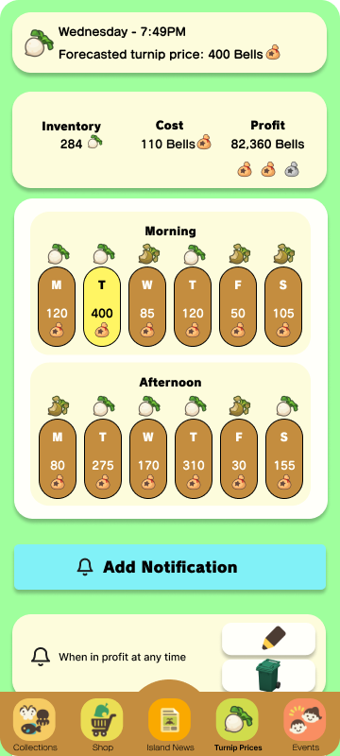

#### 5-Second Testing

##### Goal

To measure how well the design quickly communicates its intended context (That it is a turnip price tracker).

##### Methodology

Users were told that they would be **shown a screen for 5 seconds** and they would be **asked a question** afterwards. The users were not told which screen they would be looking at until the test had begun. The users were not informed of the question until the end of the 5 seconds. The users were given a countdown before they were showed the Turnip Prices screen, but there was no countdown during the test.

After the 5 seconds, users were **then asked “What do you see?”** and their responses were noted.

##### Insights

Most users (#1, #2, and #4) understood that the app was for tracking turnip sale prices. One user thought the app was a calendar somehow related to onions (#3), but they had not played the game. Interestingly, #5 who had played the game assumed the screen was about the in-game weather. Based on these findings I believe that there should be **additional 5-second tests** on the **same screen** with a **group of users who play the game** to see if there is still uncertainty on the context of the screen and whether the UI should be altered. If so, A/B testing could be conducted to validate future design choices.

All users mentioned the calendar apart from #2, who mentioned that the screen showed “something about morning and afternoon”. These findings indicate that the **concept of specific dates or times** were **well communicated** in a short period by the UI.

Some users (#3 and #4) mentioned that one of the times in particular was highlighted yellow. This indicates that some users were **able to interpret a detailed understanding** of the context of the application (as opposed to just the fact time is a component of the screen).

Additionally, user 4 who has played ACNH suggested that I specify what morning and afternoon correlate to in regards to the Nook’s Cranny shop hours. I would therefore like to explore this further by **conducting an A/B test with ACNH players** comparing the current calendar and the calendar with the additional information to validate whether this change should be implemented.

#### 

#### First-Click Testing

##### Goal

To validate the effectiveness of the “Add Notification” call to action button.

##### Methodology

Users were given the prototype on the Turnip Prices screen and asked to **add a notification.** They were not aware that this was a first-click test until the test had concluded.

##### Results

Every user pressed the “Add Notification” button first (and proceeded to successfully add a notification. This validates the impact of this call to action button. Furthermore, all users were able to go through the following prompts to add a notification.

Interestingly, despite having played the game, #1 mentioned that the colour of the call to action button did not appear to fit the theme at all and suggested that we maybe make the colour dark brown like the other elements. They mentioned that the current colour makes the button “pop more” but believed that due to the size of the button, it would still maintain its effectiveness if there was a colour change that they perceived to be more fitting for the theme.

Therefore, **a future A/B test** could be conducted with the existing colour and the brown colour for the call to action button to see what users aesthetically prefer. Furthermore, an **additional first-click test** with different users can be conducted to validate whether the button is still as effective. The **call to action button could then be modified** if the data supports it.

### 

### **Event Tracker - Berk**

#### Test Users

1. Early 30s (M), gamer, non ACNH player, on Android w/ Chrome.
2. Late 20s (F), non-gamer, non ACNH player, on iOS w/ Safari.
3. Early 20s (F), gamer, non-ACNH player, on MacOS w/ Opera.
4. Early 20s (M), gamer, non-ACNH player, on iOS w/ Safari.
5. Early 30s (M), gamer, non-ACNH player, on iOS w/ Safari.

#### 5 Second Test

Requested users to look at the events screen for 5 seconds, and report back what they remember from the shown screen.

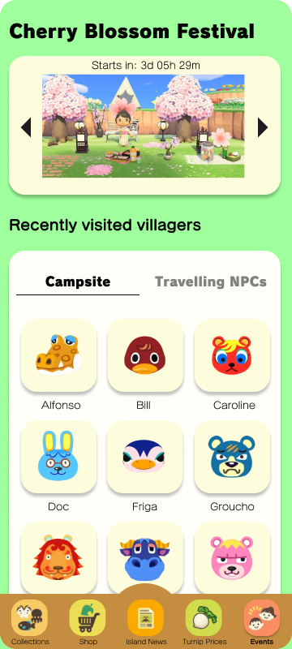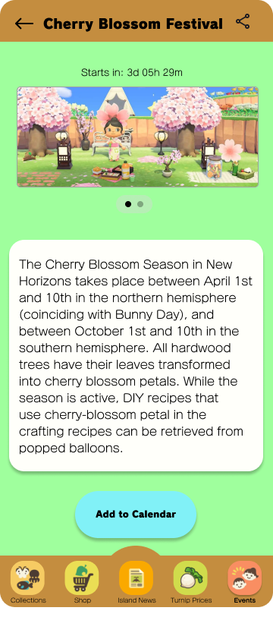

##### Results

Users have mostly remembered the villagers that appeared on screen (User #2 and User #4 have said animals, haven't played the game before). User #1 has said that it looks like a screen to display events with attendees listed below, confusing visiting villagers with event attendees. User #5 stated that they remember there is a timer for an event and those characters listed below are joining the event, same as User #1. General outcome is that the main events listed on banners are being confused by visiting villagers, which is another type of an event.

#### First Click Test

##### Prompt

You launch the application and you want to review your recently visited villagers and current events, and you want to save the event to your calendar.

##### Results

User #1 clicked on the Events tab at the bottom navigation bar, took 2 seconds to find the events tab and click. User successfully followed the path: Events tab -> Click on Event Banner -> Pressed Add to Calendar button below, no hesitations were present. User #2 clicked on the Events tab at the bottom navigation bar, taking 4 seconds to find the events tab. User followed the path Events tab -> Click on Event Banner -> Click on Add to Calendar button. No hesitations were present, same as User #1. User #4 took 3 seconds to click on the events tab at bottom navigation, clicked the banner on the events page, went to event detail and pressed the button to add the event to the calendar. They did not hesitate and all went great. User #5 was able to find the events tab after 3 seconds, pressed on the event banner and navigated to event detail, and found the button to add to the calendar next. User #3 have navigated to the events page, and scrolled down the villagers when trying to find the event, this is the most different case in all users, however then scrolled up and clicked the event banner, and added it to the calendar. Mostly, UI flow seems to be correct, however the villagers listed may be distracting users from main events such as cherry blossoms.

### **Collection Manager - Livio**

#### Test Users

1. Early 30s (F), non-gamer, not an ACNH player, on iOS w/ Safari.
2. Early 30s (M), gamer, ACNH player, on Android w/ Chrome.
3. Late 20s (M), gamer, ACNH player, on Android w/ Chrome.
4. Early 20s (M), gamer, not an ACNH player, on Android w/ Brave.
5. Early 40s (M), gamer, ACNH player, on iOS w/ Safari.

#### A/B Testing

Tested a **different colour** on the action buttons of the collection screens. The proposed change is intended to match the colour of the CTA buttons on the rest of the app, instead of the current yellow colour.

|  |  |
| --- | --- |
| Screen A - original colour | Screen B - alternative colour |

##### 

##### Results

Users almost unanimously picked the yellow colour for the buttons. The general response was that it matches the app vibe, while the light blue colour stands out too much and it becomes annoying. One of the users (#3) also mentioned that he associates the yellow colour with something to interact with or to fill in, so it seems more natural to him.

One of the users (#4), though, picked the light blue colour, stating that the yellow colour could be a bit difficult to see due to lack of contrast with the background colour. This user also claimed that using a different colour can give some hierarchy to the types of buttons.

Based on these findings, we’ll **keep the yellow colour** for the buttons on this screen, while in the future we can test adding some border colour to help increase the contrast with the background.

#### Usability Test

Users were required to **add a crab to their collection**, starting from the Home screen, to determine how intuitive the app is for users of different tech savviness.

##### Insights

Users tend to either scroll through the first collection shown to them and then tap on the category where they think the critter to be added is, or just freeze for a second and then tap on the category. There is **low to no use of the search bar** when searching for the critter. **Making it stand out more** should be tested to encourage its use.

# 

# Appendix A - Screenshots

## Island Newspaper

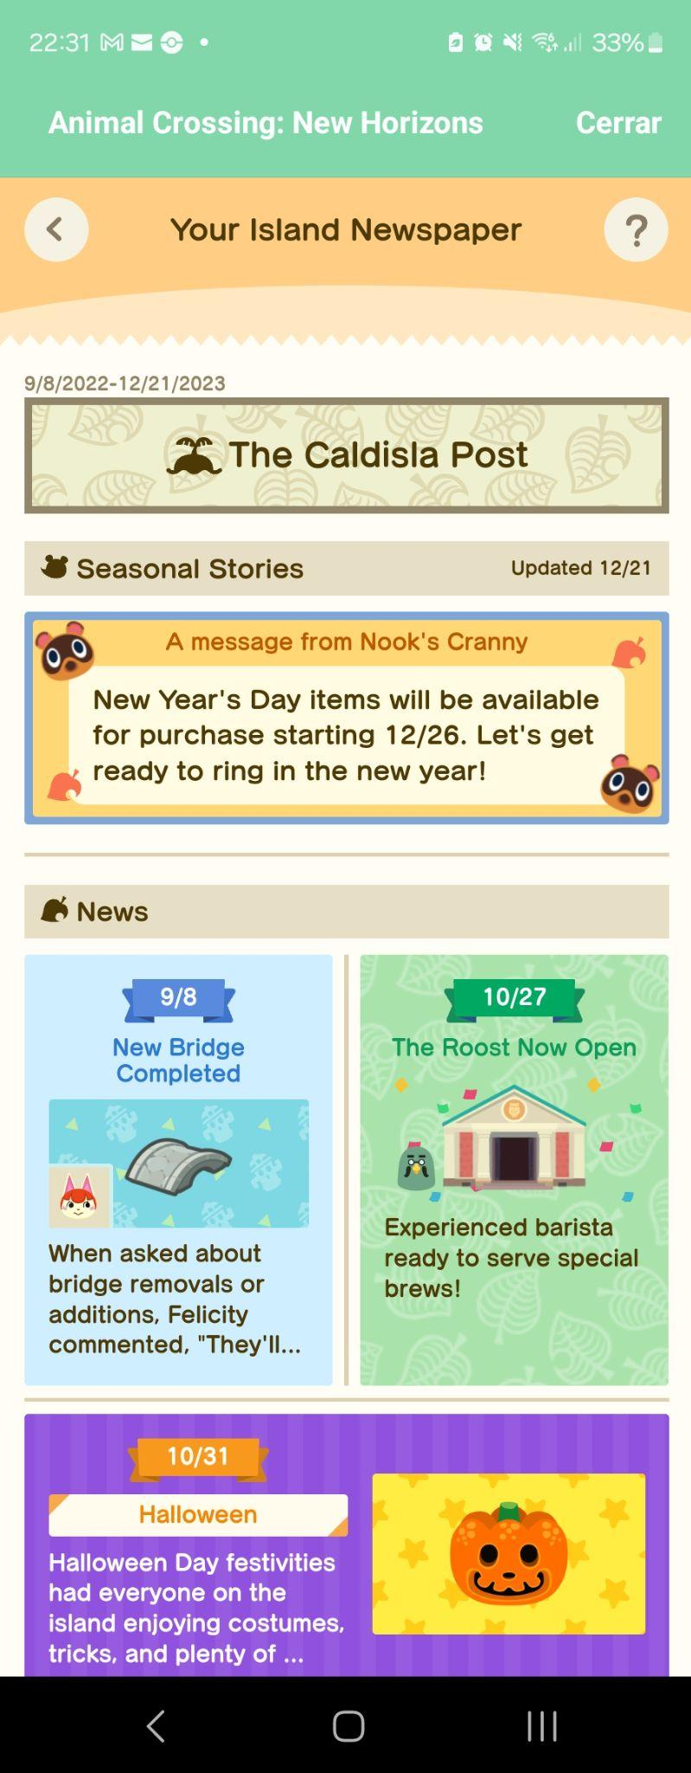

# Appendix B - Interview Responses

## *Interview #1*

1. Tell me about your experience playing ACNH.

Got island to 5 stars, won the lottery, quit playing because too much money and bored.

1. How do you feel about the collection/progression system in ACNH?

It took a long time because she didn’t know when/how to catch certain bugs/fish, never finished collecting.

1. What do you spend most of your in game time doing?

Designing the island layout and tracking turnip prices.

1. How many hours have you played ACNH for?

~150

1. How would you describe yourself as a gamer?

Completionist, like having specific goals to work towards, enjoy games with short game loops and systems, processes, or other things that can be optimized and improved on as you learn the game.

1. What are your thoughts on our app concept?

It would be helpful to be able to see information about the game without having to log in to the game. Sometimes you open the game just to check if anything interesting is going on and find out nothing is, but an app that could tell you about your game could waste less time.

1. We aim to implement the following features in our companion app: [list features], what are your thoughts on these features?

Like the shop from your phone feature, as well as villager and event tracking. Chat doesn’t seem necessary. Questionable on the map being necessary, or if the villager tracker and map are basically the same feature.

1. Are there any features that we have not included in our concept that you would consider adding?

Would like to see a custom pattern browser that’s more robust than the in-game one to be able to search, filter, and load new patterns.

1. If you would consider using our app, please walk me through how you can see yourself using it.

Mainly use it to look at villagers to find out where they are, and to check on turnip prices. Would also use it to find out which villagers are on the island “so that I can acquire them.”

1. We aim to make the app free with ads, with an optional $3-4 purchase to remove ads. What are your thoughts on this price point?

This is an acceptable price point, but only because the app is free and she would not pay to remove the ads, instead just watch them when they come up.

## *Interview #2*

1. Tell me about your experience playing ACNH.

Started quite some time ago, don’t remember when. Nowadays playing it from time to time, as a way to relax by interacting with the island visitors.

1. How do you feel about the collection/progression system in ACNH?

I’m happy with its progress, even though now I have to wait because of having already gathered everything that was available for this season.

1. What do you spend most of your in game time doing?

Mostly gathering resources for crafting and collecting items.

1. How many hours have you played ACNH for?

About 145 hours.

1. How would you describe yourself as a gamer?

More casual, trying to enjoy the game at my own pace.

1. What are your thoughts on our app concept?

I like the idea and it would make me play ACNH more by notifying me about what’s going on.

1. We aim to implement the following features in our companion app: [list features], what are your thoughts on these features?

I would be able to see when something interesting is going on on my island and log in for a while on those situations, or buying turnips on Sundays and log in when the prices are high in the app, so I would definitely use at least those features.

1. Are there any features that we have not included in our concept that you would consider adding?

There’s nothing coming to my mind that hasn’t been covered already [we went through some of the features for the previous questions].

1. If you would consider using our app, please walk me through how you can see yourself using it.

I would be using the app mostly to keep track of what’s happening on the island from time to time and to jump into the game if something interesting is going on, or if it is a good time to sell my turnips for a big profit.

1. We aim to make the app free with ads, with an optional $3-4 purchase to remove ads. What are your thoughts on this price point?

The pricing seems reasonable. I would use it for free at first and if the app enhances my QoL I would purchase the full version to support the devs.

# Appendix C - Citations

## Target audience assumptions

Animal Crossing Wiki (2024). Audie.   
Retrieved from: <https://animalcrossing.fandom.com/wiki/Audie>

phubans.(2020, August 14) 89-Year-Old Grandma's New Horizons Island Tour [Video] <https://www.youtube.com/watch?v=didkW-LOWCs>

## Target audience citations

List of banned video games by country. (2024).   
Retrieved from: <https://en.wikipedia.org/wiki/List_of_banned_video_games_by_country#cite_note-37>

Sensor Tower. (2021). ACNH.Guide for Animal Crossing - Apple App Store - China - category rankings, keyword rankings, sales rankings, research, performance, and growth metrics. Retrieved from: <https://app.sensortower.com/overview/1504317399?country=CN>